Decision of the European Court of Human Rights

Hamdi Akın IPEK v. Turkey, no. 4158/19, 21 September 2021

LEGAL ASSESSMENT

Below is the legal assessment of the Hamdi Akın IPEK v. Turkey inadmissibility decision issued by the European Court of Human Rights (ECtHR) on 21 September 2021. This legal assessment has been made by examining the following documents, all of which are included in the case file submitted to the ECtHR.
- The application form dated 12 December 2018 drafted in English and its appendices (48 annexes (697 pages) in total).
- The document titled "Additional Explanations", consisting of 20 pages, submitted as “Annex 1” to the ECtHR with the application form.
- The report titled “Some information concerning the process of proclaiming the Gülen Movement as a terrorist organisation under the name of FETÖ/PDY” (submitted to the ECtHR in the exhibits of the application form as “Annex 4”).
- The letter and document on current developments submitted to the ECtHR on 15 November 2020 (consisting of 5 pages in total).
- Constitutional Court application form dated 18 November 2015 (51 pages in total).
- Summary of the Constitutional Court application form dated 18 November 2015 (9 pages in total).
- ECtHR's decision of inadmissibility dated September 21, 2021 (19 pages in total).

CONSIDERATIONS ON THE FACTS (“EN FAIT”) (§§ 1-69)

    - The facts regarding the present case (Les circonstances de l'espèce) (para. 2-63)

- A comparison of the contents of the ECtHR decision (“les circonstances de l’espèce, §§ 2-63), the application form and the 20-page Annex 1 titled “Additional Explanations” reveals the following conclusions with regard to the way the facts are addressed:
- Although the Applicant states that the national authorities prepared false reports and his companies were seized based on these reports and explains his claims in reference to the annexes of the application form and Annex 1, the part of the ECtHR decision addressing the facts does not include the Applicant's version of the facts. With regard to the facts, the ECtHR decision only includes the opinion of the experts who the Applicant claims to be partial (chosen on purpose), decision of a criminal judge of peace chosen on purpose (Ankara 5th Criminal Judgeship of Peace), and the one- sided decision of the Constitutional Court, which has lost its independence after the coup attempt. In other words, in the part of the ECtHR's decision on facts, only the facts that can be a basis for the inadmissibility decision are included, while the Applicant's version of the facts has been omitted. For this reason, it is obvious that the part of the decision regarding the facts is not written as an impartial manner, and since the decision is made without being communicated to the Government, this form of writing is striking and in contravention of the principle of impartiality. If the ECtHR was going to write the facts based only on official documents, then it should have included the Applicant's opposing views on what was written in each document, the petitions of objection or the Constitutional Court application form and the ECtHR application form. Since the Applicant's version of the facts have not been included and the decision of the ECtHR has been made without any reference to certain incidents included in the application form and Annex 1 which form the basis of the violations, the conclusion to be reached is that a biased method is followed in the writing of the facts. For example, certain phrases are not included in any way in the decision, namely seizure of media organs by police raid, obstruction of operation of two TV stations and two newspapers for one day, immediate dismissal of editors and about 100 journalists, and complete closure of one radio station, two TV channels and two newspapers on March 1, 2016, and termination of the existence of media companies on 1 March 2016 despite the prohibition in Articles 28 and 30 of the Constitution. The complaint regarding violation of freedom of the press is rejected with the same one- sentence reason of the Constitutional Court decision.
- The following issues have been observed regarding the part of the ECtHR decision on the facts:
- Although it is written in the second paragraph that the facts subject to the application started before 15 July 2016, the coup attempt of 15 July 2016 seems to have pervaded the spirit of the decision. Before 15 July 2016, there had been no terrorist organisation called "FETO/PDY" which was declared a terrorist organisation with a final judicial decision, and there had been no act of violence attributed to the Gülen Organisation before this date. According to the decisions of the ECtHR, in order for a natural or legal person to be accused of being a member of or aiding a criminal organisation, it must have been determined beforehand that the said organisation is a "criminal organisation" by a final court decision (Parmak and Bakır v. Turkey, no. 22429/07 and 25195/07). Although the Applicant's complaints are related to the facts before 15 July 2016, the 15 July 2016 coup attempt is taken into account in many parts of the decision of the ECtHR, and it is stated that “FETÖ/PDY is a terrorist organisation, the National Security Council (NSC) describes this organisation as an “illegal structure with a legal appearance” (§ 10), and the Applicant's companies also made donations to educational institutions before 15 July 2016, so the seizures of the companies are legitimate”. The relevant NSC decision referred to in the ECtHR decision was taken on 26 May 2016, long after the trustees were appointed to the Applicant's companies on 26 October 2015. This decision was not present on the dates of the donations alleged to form the basis of the trustee appointment decision. In a Rule of law, no organisation can be described as a criminal organisation until it has been declared a criminal organisation by a court decision; no organisation can be declared illegal unless determined by a court order; The "illegal structure with a legal appearance" is a political and illegal characterisation and has no legal validity. Since the NSC is not a judicial body, it cannot characterise any structure as a criminal or terrorist organisation. Since the decisions of the NSC are “confidential” and not published they do not have the quality of a legal norm. The decisions of the NSC are not binding, and they are only advisory to the Government (Art. 118 of the Constitution). NSC decisions cannot impose any obligations on individuals. The NSC is not a legislative body either, which could take decisions as if it were enacting laws and these decisions would bind individuals. In Annex 4, these issues are stated as follows:
- Both meetings and decisions of NSC which comprises of some ministers and high- ranking soldiers and presided over by the President are confidential. However, after each meeting, a short press statement is released and brief information about the topics covered in the meeting is provided. Gülen Movement was not mentioned as a terrorist organization in any of the press releases issued after the meetings which took place from 26th February 2014 to 26th May 2016. The concept of “Parallel State Structure” was used for the first time after the NSC meeting of 30th December 2014.¹ After the NSC meeting held on 26th May 2016, the fact that Gülen Movement is accepted as a terrorist organization was expressed in the following words: “The actions in order to provide our citizens’ peace and safety, public order, the stage reached in the fight against terror and terrorist, the precautions taken against the parallel state structure that is a terrorist organization were discussed.”² The fact that Gülen Movement is accepted as a terrorist organization was declared for the first time with this statement on 26th May 2016, and it is publicly known that the said Movement is meant with the term “parallel state structure” used in this statement. It should not be forgotten that more than 200.000 persons who were indicted after 15th July 2016 were accused of “membership of a terrorist organization”; not of membership of the parallel structure. There is no such crime defined as “membership of parallel structure” in the criminal codes either. Accordingly, the first date that may be taken into consideration in terms of the accusation of membership of a terrorist organization is the date of 26th May 2016.
- One day after the NSC meeting, President Erdoğan, in his speech on 27th May 2016 in the province of Kırşehir, said that “We took one more new decision yesterday (in NSC meeting). We said that it is an illegal terrorist organization under the legal appearance. We took the recommendation decision of Fetullahçı Terrorist Organization and sent it to the Government. We are waiting for the cabinet decision from the Government. We will register them as terrorist organization as well. They will stand trial in the same category of what PYD, YPG and PKK are.”
- After the Cabinet Meeting on 30th May 2016, the Deputy Prime Minister and Cabinet Spokesman Numan Kurtulmuş expressed the following statement on the issue: “It was highlighted in the previous NSC meetings that Parallel State Structure (PSS) is an illegal organization with legal appearance (!), and it was also stated in the previous NSC meetings that total fight against Parallel State Structure (PSS) was targeted by the State. With the NSC’s recommendation decision, it has been entered a new phase of fight against the Parallel Structure. The PSS was designated as a terrorist organization for the first time in the NSC meeting as a recommendation decision and the main framework of the fight afterwards was converted into the way to fight against a terrorist organization. Consequently, all the things required will be implemented both by the government and by the respective judicial bodies, the implementation will continue without disruption.” As understood from this statement, the NSC’s recommendation decision was accepted by the Council of Ministers and then this position was declared to the public. Thus, Gülen Movement was declared as a terrorist organization for the first time with a cabinet decision of 30th May 2016 based on the NSC decision of 26th May 2016 with the executive branch’s initiative and not by any independent courts based on concrete criminal evidence.”
  - The ECtHR decision states, without specifying a date, that “FETÖ/PDY was ruled to be an armed terrorist organisation according to national judicial decisions” (§ 10). However, the 11th paragraph of the Constitutional Court's decision states that the Gülen organisation was declared a terrorist organisation for the first time with the final decision on 26/9/2017 (Annex 37, § 11). As explained in detail in Annex 4, FETÖ/PDY was determined to be a terrorist organisation for the first time with the General Assembly of Penal Chambers of the Court of Cassation’s decision dated 26 September 2017, and the Applicant's companies were seized on 26 October 2015. At this date, there was no terrorist organisation called FETÖ/PDY and it is illogical to be helping an organisation that does not exist. In short, it seems that the ECtHR decision deliberately avoids stating when FETÖ/PDY was declared a terrorist organisation. In fact, these issues are explained in detail in Annex 4 as follows: “With the General Assembly of Penal Chambers of the Court of Cassation’s decision on June 24, 2008, it was ruled in a final decision (res judicata) that the Gülen Organisation was not a terrorist organisation. An act of violence was attributed to this organisation for the first time on July 15, 2016, and the organisation was declared a terrorist organisation for the first time with the final decision on 26 September 2017” (see, Annex 4, §§ 1-24). Despite this fact, the Applicant's views are not included in the decision of the ECtHR in any way, and the statements that the Constitutional Court used in other decisions are simply repeated in the ECtHR decision as if they were established.
  - Likewise, the dates of the NSC decisions are not specified in any way either: only the evaluations of the NSC are included (§ 10) which state that that the Gülen Organisation carried out illegal activities under a legal appearance (which can only be decided by the court). However, the NSC made evaluations in this regard for the first time in its recommendation on 26 May 2016, and trustees were appointed to the Applicant's companies on 26 October 2015. The Constitutional Court decision also stated that the Gülen organisation was declared a terrorist organisation for the first time in the NSC decision on 26 May 2016 (see Annex 4, para. 18-20). Despite this fact, by not specifying a date, the ECtHR has led to the misunderstanding that the Gülen Organisation has been accused of illegal activities for a long time, and that the Applicant knew about these issues before the date of the trustee's appointment. If the views of the Applicant in Annex 4 were also included in the ECtHR decision, it would have been appreciated by the readers that the decision violated the principle of non- retroactive application of criminal laws.
  - Although the Applicant had nothing to do with the coup attempt of 15 July 2016 and trustees had been appointed to his companies long before this date (26 October 2015), detailed information about the coup attempt is given, regardless of it being accurate or not. For example, it is written that the Chief of the General Staff was taken prisoner (§ 4), and this allegation is false. If it were written in the decision that the NSC declared the Gülen Organisation to be a legal-looking illegal organisation or to be a terrorist organisation for the first time on 26 May 2016, it could be clearly seen that the principle of non-retroactive application of criminal laws had been violated because, as explained in the application form and its annexes, the only charge attributed to the Applicant would be clear: donating to an association and foundation that he founded, enabling construction of a university he founded by making a donation, donating to another private university in 2012, and donating to public schools and institutions (all before 2015). This situation is stated in Annex 1 as follows: “All of the donations by the companies were made as prescribed by the laws and articles of association to the family foundation, Ipek University, Turgut Özal University, Kimse Yok Mu Association, Ministry of Education and Prime Ministry" (see Annex 1, § 53).
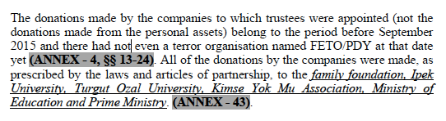
  - In short, all the said association, foundation and universities were institutions operating legally at the time of all the donations; making donations to legally founded institutions cannot be considered as a crime when it is committed (before 2015) (Article 7 of the ECHR). The main accusation (donating to an association, foundation, and university) specified in the application form and its annexes is not mentioned in any way in the ECtHR decision (see § 40): donations to an association, a foundation and two universities are shown as if they were aid to the terrorist organisation and this situation has been covered up.
  - In paragraph 12 of the decision, the following statement is taken from the Constitutional Court's decision regarding “FETÖ/PDY”:
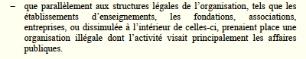
  - This allegation is extremely important for the outcome of the application, and no determination had been made regarding the Gülen Organisation prior to the seizure of the companies, the subject of this application. All the determinations regarding Gulen Organisation have been made after 26 May 2016 (see, Annex 4, §§ 1- 24). Although the dates regarding the aforementioned determinations are stated in detail in the Constitutional Court decision and in Annex 4, when these determinations started to be made are hidden in the ECtHR decision and it is intimated that the seizure of the companies, the subject of this application is therefore legitimate. However, trustees were appointed to the companies, the subject of this application, on 26 October 2015 on the grounds of allegations relating to a time long before this date. If it were stated that the said determinations were made after 26 May 2016, it would be revealed that trustees were appointed to the companies in clear violation of the principle of non-retroactive application of criminal laws, and this inadmissibility decision would not be accepted by the 3 judges of the ECtHR.
  - In paragraphs 18 and 19 of the ECtHR decision, it is stated that a panel of experts was formed by the office of prosecutor and that this panel issued a report on 16 October 2015 in which it reached certain conclusions. However, the Applicant’s claim that the panel of experts issuing this report abused its powers is not stated, neither are his claims that that the experts were not selected from among the "experts whose names are on the expert list in the courthouse", that this committee was specially formed, that the head of the panel was later appointed as the rector of Anadolu University as a reward, and that the committee prepared a biased report (Annex 1, § 7). Regarding the findings of the expert panel, the Applicant's views and documents which later showed that these allegations had been untrue, were disregarded by the ECtHR. For example, the allegations of the expert panel, including the money laundering charge, were not included in the indictment brought later, which shows that the opinions of the expert panel turned out to be untrue. Although these points were stated in Annex 1, they are not included in the part of the ECtHR decision describing the facts.
  - The following facts, which are clearly stated by the Applicant (Annex 1, § 14) and which are important in terms of complaints, are not included in the ECtHR decision:
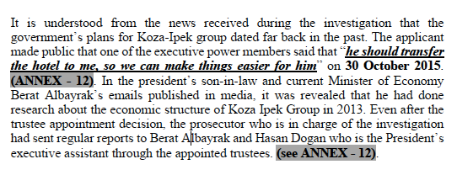
  - In fact, these facts show that the political authority, especially President Recep Tayyip Erdogan, is behind the appointment of trustees to 18 companies. They show that the head of the expert panel was appointed by the President as a rector, the Applicant was accused of aiding the Gülen organisation, and the head of the expert panel also made statements expressing hostility to this organisation and was not impartial. Therefore, the Applicant claims that the allegations in the expert report, upon which the first trustee appointment decision was based, were fabricated by a biased expert panel and states that it constitutes evidence that the first trustee appointment decision was made illegally. Accordingly, if this information was not to be written in the ECtHR decision, it should have at least been asked to the Government whether these allegations were true or not. Since the ECtHR has made a decision without communicating these allegations to the Government and without writing them in its decision, it has hidden these facts from those who read or will read the decision (and from public scrutiny).
  - The paragraph 20 of the ECtHR decision states that the public prosecutor requested the appointment of trustees to 18 companies belonging to the Applicant on 20 October 2015 and includes the content of this request. The Applicant could not submit the prosecutor’s request dated 20 October 2015 to the ECtHR because he did not have it. Considering that the ECtHR wrote the application only on the basis of the documents in the case file, without communicating to the Government, it is not clear how the ECtHR obtained this request and how it relied on a document not included in the case file. It goes without saying that writing a decision based on a document not included in the case file violates the right to a fair trial and casts a shadow on the impartiality of the ECtHR. The annexes submitted by the Applicant to the Court are as follows in chronological order, and the prosecutor's request on 20 October 2015 is not among them:
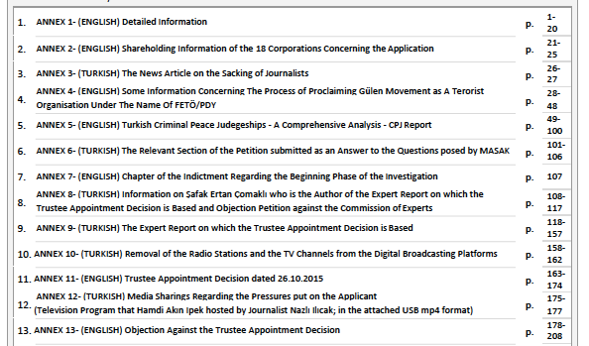
  - The 21st paragraph of the decision states the reason for the appointment of trustees in the Ankara 5th Criminal Judgeship of Peace’s decision:
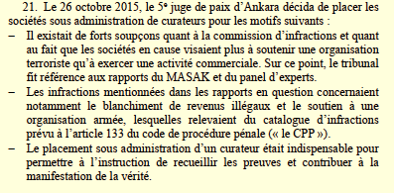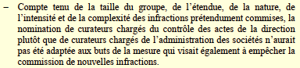
  - As it can be understood from the trustee appointment decision on 26 October 2015, trustees were appointed to 18 companies based on charges of “money laundering (TCK art. 282) and aiding a terrorist organisation (TCK art. 220/7)”. First of all, the crime of aiding an organisation (Art. 220 § 7 of Turkish Penal Code, TPC) is not of the catalogued crimes provided for in Article 133 of the Code of Criminal Procedure (CPP). The crimes of "providing weapons to a terrorist organisation” and “armed organisation" (Articles 314 and 315 TPC) are provided for in Art 133 of the CPP as catalogued crimes; but aiding to an organisation (Art. 220 § 7 TPC) is not. In addition, it was stated in the application form and its annexes that these accusations were not based on any material facts and it was revealed in the indictment brought later. Although the indictment was sent to the ECtHR (Annex 39), the content of this indictment is not included in the ECtHR decision. Only the accusations are included, and as it can be understood from the decision, the Applicant was not charged with "money laundering crime". In the indictment on 13 June 2017, the Applicant was charged with "financing of terrorism, membership of a terrorist organisation, abuse of trust, opposition to the Tax Procedure Law No. 213, opposition to the Law on Financial Markets" (§ 39). “Donations made to institutions (universities, associations, foundations) and investments made in media companies, which were closed during the state of emergency,” which was announced 9 months after the date of the trustee appointment (on 13 June 2017), are only cited as evidence of the accusation of membership of a terrorist organisation (Annex 1, §§ 59-60). None of these crimes, including financing of terrorism, are among the catalogue crimes provided for in Article 133 of the CCP. The indictment brought against the Applicant shows that the accusations specified as reasons for the criminal peace judgeship's decision to appoint trustees to 18 companies on 26 October 2015 were unfounded. Thus, it becomes clear that trustees had been appointed to 18 companies (without legal basis) before the conditions in CCP article 133 (such as the existence of a strong suspicion of crime) were met. The content of the indictment on 13 June 2017 and the Applicant’s views on this matter are not included in the ECtHR decision, and the ECtHR has concealed the fact that trustees were appointed to 18 companies unlawfully and that they were appointed without legal basis for interference with the right to property and freedom of the press. In fact, the Applicant explained this issue in detail both in the application form and in Annex 1 (see Annex 1, §§ 34, 42, 43, 45, 54).
  - Furthermore, the trustee appointment decision was on 26 October 2015, and there was no terrorist organisation called “FETÖ/PDY” at that date that was established with a final court decision. The accusation of aiding a terrorist organisation that did not exist at the date of the appointment of trustees is also baseless (Parmak and Bakır v. Turkey, no. 22429/07 and 25195/07). The existence of a terrorist organisation with this name was acknowledged for the first time on 16 July 2016 by Prime Minister Erdogan, and this issue was stated in Annex 4, submitted to the ECtHR (Annex 4, § 47).
- Even though Gülen Movement was declared as a terrorist organization on 30th May 2016 by the Council of Ministers, President Erdoğan said that the coup attempt was made by soldiers who are the members of parallel structure in his statement made at İstanbul Airport on 16th July 2016 at about 3.21 A.M. and he added that “the fact that this group is an armed terrorist organization HAS COME TO LIGHT”. Bülent Arınç, who was one of the founders of AKP and former chairman of Turkish Parliament and former Deputy Prime Minister, made the statement on 21st July of 2016 that “I found out that the armed terrorist organization was Fetullahist in that night”. İbrahim Kalın, Deputy Secretary General and Spokesman of the Presidency stated on 26th August 2016 that Turkey “faced a new terrorist organization since the date of 15th July 2016”. Mehmet Yılmaz, Vice President of High Council of Judges and Prosecutors (renamed as Council of Judges and Prosecutors by virtue of 16th April 2017 Constitutional amendment) said that “You know that there is a debate on whether this organization (Gülen Movement) is an armed terrorist organization or not. In order this (organization) to be criminalized, it required that this (organization) was determined as an armed terrorist organization. … When that day (15th July 2016) at the night of the coup attempt, very clear and undeniable evidences came out which showed that this organization was a terrorist organization, Ankara Chief Prosecutor’s Office launched an investigation in accordance with Article 314 of the Turkish Penal Code which regulates the crime of membership of an organization. … Consequently, Ankara Chief Prosecutor’s Office issued arrest and custody orders for 2745 judges and prosecutors for membership of an armed terrorist organization.”
  - The last sentence of the 21st paragraph of the ECtHR decision states that trustees were appointed to "prevent the commission of new crimes" (empêcher la commission de nouvelles infractions), but Article 133 of the CPP does not foresee this purpose. This reason alone makes it clear that the appointment of trustees to 18 companies is illegal.
  - To summarise, trustees were appointed to the Applicant's 18 companies based on Article 133 of the CCP. In order to appoint a trustee to 18 companies in accordance with CCP article 133, “There must be a strong suspicion that one of the catalogue crimes continues to be committed within the framework of each company’s activities, and the appointment of a trustee must be necessary to reveal the material truth.” Firstly, trustees were appointed to the companies on charges of "money laundering and aiding (financing) a terrorist organisation", and it was revealed that these accusations were unfounded and were not included in the indictment. In other words, trustees were appointed without "strong suspicion of crime". There was no terrorist organisation in question at the date of the decision. "Financing of terrorism" is not among the catalogue crimes specified in Article 133 of the CCP. Despite this, the Constitutional Court also stated the accusation of financing terrorism as a reason (see, below). Therefore, interference with the right to property (appointing trustee to 18 companies) lacks a legal basis. In addition, the sole purpose of the appointment of trustees provided for in Article 133 of the CPP is to reveal the material truth, that is, to "obtain evidence", and “prevention of new crimes” is not stipulated in this article. There is only one legitimate aim stipulated in Article 133 of the CPP: to reveal the material truth. Accordingly, the trustee decision violates Article 133 of the CPP, and the interference with the right to property lacks any legal basis. Although all these were clearly explained in English in the application form and Annex 1, the indictment was purposefully omitted from the ECtHR decision, and the fact that the trustee appointment was contrary to Article 133 of the CCP and the interference with the right to property lacked a legal basis was concealed in the ECtHR decision. In the part on relevant Law (Droit interne pertinent) in the ECtHR decision, a short summary of Article 133 of the CPP is provided without its full translation (§ 66), and therefore it is concealed that the decision on the appointment of trustee was unlawful.
  - Paragraph 22 of the ECtHR decision refers to the press release of the Ankara Chief Public Prosecutor Office, but a translation of the press release, which allegedly violated the presumption of innocence, was not provided in the decision, and its contents were hidden. On the other hand, the Applicant attached the press release to the application form. If the press release had been translated, it would have been easier for readers to check whether the Applicant’s claim about violation of the presumption of innocence was true. If the statements in the relevant part of the Office of Prosecutor’s press release (paragraphs 11 and 12) had been included in the decision, it would have been seen that these statements violated the presumption of innocence, since the prosecutor’s office used expressions that implied that the Applicant had committed the alleged crimes without using such expressions as “allegedly” in its press release on 27 October 2015 (see Annex 44).
  - Paragraph 24 of the ECtHR decision states that the Applicant objected to the trustee’s decision, and paragraph 25 includes objections of a biased expert in detail. However, paragraph 25 does not point to the Applicant’s argument that the experts in question “do not consist of experts pre-determined by the courthouse” (Application form, § 7). Although the Applicant used an argument consisting of four lines regarding the expert panel, this secondary problem was detailed in 11 lines in the ECtHR decision (§ 25). The Applicant’s argument in this regard is as follows (Annex 1, para. 16):
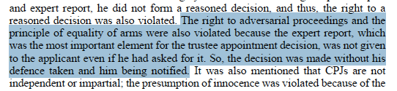
  - In the petition of objection on 2 November 2015, the ECtHR application form and Annex 1, the Applicant explains in detail that the trustee appointment decision on 26 October 2016 was given in violation of Article 133 of the CCP and Articles 28 and 30 of the Constitution, and that the interference with the right to property and freedom of the press lacked legal basis (see Annex 1, §§ 15-18). However, the ECtHR did not state the Applicant’s concrete arguments as to whether there was a legal basis for the trustee decision and wrote in abstract language that the Applicant argued that “the legal conditions for the trustee appointment were not met, he objected to the expert reports and the decision was implemented without being published in the Trade Registry Gazette” (see, § 26).
  - On the other hand, if the Applicant’s concrete arguments regarding the lack of legal basis (principle of legality) for the interference with the right to property and freedom of the press were stated in the ECtHR decision, it would have been seen by any reader of the decision that the reason for the trustee decision was at least dubious or refuted. As is known, the most important issue in terms of violations of freedom of the press and right to property is whether there is a legal basis for the interference with these rights. If there is no legal basis or if the practice is against the law despite the presence of a law, it should be decided that the rights in question have been violated directly. The Applicant detailed the arguments in the petition of objection, in the application form and in Annex 1 (Annex 1, §§ 15-17) and attached the petition to the application form as an annex. The following points were highlighted in the petition of objection as it was submitted to the ECtHR: (“October” must be “November”).
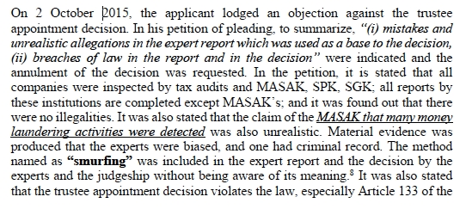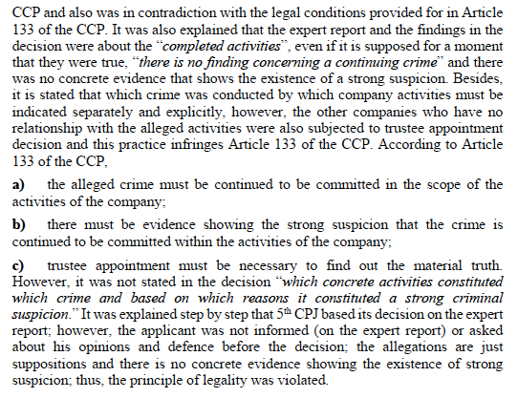
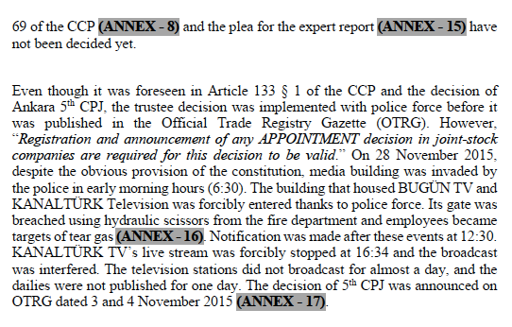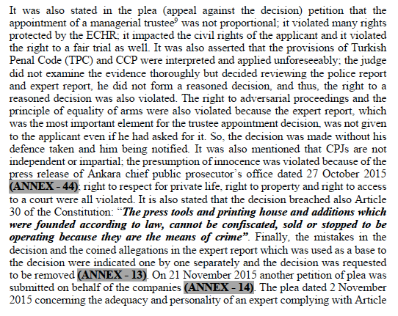
  - If the Applicant’s reasons for objection regarding the lack of legal basis of the intervention and especially his arguments regarding Article 30 of the Constitution had been written in paragraph 26 of the ECtHR decision, it would have been understood that the reason in the ECtHR decision regarding freedom of the press was ill-founded in many respects, since it would have been clearly seen that appointing trustees and seizing media companies lack legal basis, and the reason in the Constitutional Court’s decision on this issue and the reason in the ECtHR’s decision were ill-founded (see, ECtHR decision, §§ 62 and 99). Referring to Articles 28-30 of the Constitution, the Applicant repeatedly stated that appointing trustees to media companies and terminating them legally on 1 March 2016 lacks legal basis, yet the ECtHR decision does not refer to Articles 28 and 30 of the Constitution anywhere, and these constitutional provisions were hidden from the reader.
  - To summarise, the Applicant put forward four lines of arguments regarding the expert witnesses and more than 2 pages of arguments regarding the violation of the principle of legality (see above). On the other hand, the ECtHR allocates 11 lines to the Applicant’s arguments regarding the expert witnesses, which are of secondary importance in terms of violations of freedom of the press and property rights, whereas the Court uses 4 lines for the Applicant’s arguments regarding the violation of the “principle of legality”, which is of primary importance in terms of violations of the rights in question. The reason for this situation and the attitude of the ECtHR, which is responsible for protecting human rights, cannot be understood.
  - The following facts, which were claimed by the Applicant regarding freedom of the press and which are extremely important for this freedom, were not mentioned in the decision of the ECtHR, and a decision of inadmissibility was issued without examination (§ 99). The reason for this is also unclear (see Annex 1, para. 18):
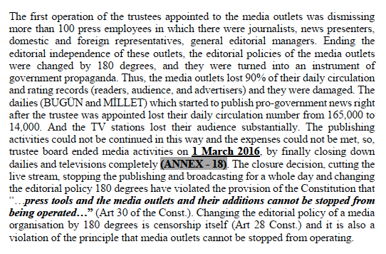
  - In paragraph 100 of the ECtHR’s decision, it is understood that the ECtHR rejects the complaint regarding the removal of the Applicant’s media outlets from digital platforms and preventing satellite broadcasts, on the ground that it was not brought forward before the Constitutional Court in domestic law. This reason is unjustifiable because the Applicant brought this complaint before the Constitutional Court. It is not clear why the ECtHR rejects the Applicant’s complaint based on false information (see, especially. Annex 26, §§ 165, 168-170):
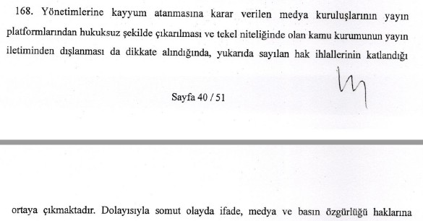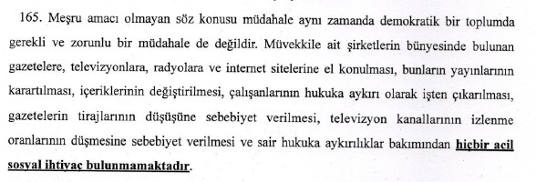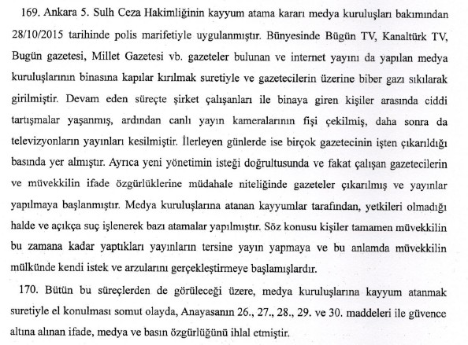
  - Although the Applicant also mentioned the following facts regarding the
removal of media outlets from digital platforms, the ECtHR has not included these facts in the decision, which are extremely important in the same complaint, and kept them from the public (Annex 1, § 8; Application form, § 8).
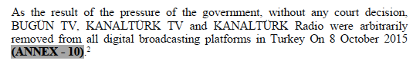
  - If the above facts (about filing the complaint with the Constitutional Court and the things that happened to the judge who decided in favour) had been included in the ECtHR decision, it would have been impossible to reject one of the Applicant’s complaints regarding freedom of the press on the grounds that domestic remedies were not exhausted (see, § 100), and the justification for the ECtHR decision would become totally ill-founded.
  - Regarding the media companies, paragraph 32 of the ECtHR decision states that the trustee appointment decision did not only target media companies but all the companies as a whole. However, the argument that the Applicant put forward on this issue, especially in the Constitutional Court and the ECtHR application form and its annexes (Annex 1, § 12), is not included in the ECtHR decision, and it is hidden from the readers that this reason, violating the principle of personality of criminal responsibility, is ill-founded, and the complaint about violation of freedom of the press is rejected with the same reason (§ 99). However, as stated in the ECtHR application and its annexes, each company has a separate ‘legal personality’. As Prof Caner Yenidunya points out, “... it is not possible either to appoint a trustee to all companies in which a suspect is a partner or shareholder. It is necessary to demonstrate with concrete evidence that these crimes are being committed within the scope of which activity of each company.” In order to appoint a trustee to each of the companies (legal entity), the evidence must be specified separately showing that the crimes committed within the framework of the activities of each company continue to be committed. In this respect, there is no justification in the decision, and there is only the claim that voluntary donations (himmet) are presented as if they were obtained from gold production and were transferred to FETÖ/PDY. This claim concerns only 2 mining companies and not the other 16 companies. For example, the reasons do not show in any way how the alleged crimes were committed and continued to be committed by media companies. In terms of media companies worth $225 million, the prosecution’s claim is also completely ill-founded, and the crime of propaganda of a terrorist organisation is not among the catalogue crimes in Article 133 § 4 of the CCP. No publication has even been prosecuted, and the prosecution considers publications within the scope of freedom of the press as terrorist activity. This statement of the Applicant is not mentioned anywhere in the ECtHR decision either, hence hidden from the public. Particularly with regard to the media companies, the ECtHR has made a decision in violation of the principle of personality of criminal liability (Each company is a separate legal entity) and Article 7 of the ECHR (see, § 99 of the Decision of the ECtHR).
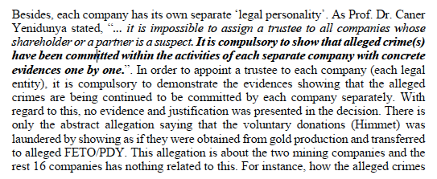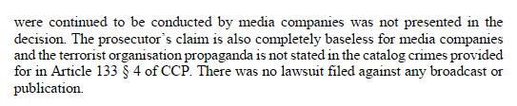
  - Furthermore, paragraph 32 of the ECtHR decision includes a reason that was not available in the reasons of the decision given by the Ankara 6th Criminal Judgeship of Peace, which rejected the objection. It is not clear from where the ECtHR got this reason, which was not included in the decision of the rejection of the objection on 12 November 2015. This shows that some untrue facts have deliberately been written in the decision, thus providing a justification for the decision of inadmissibility (§ 99 of the Decision). Paragraph 32 of the ECtHR judgment includes the following evaluation: “il (le juge) souligna que la mesure visait le groupe dans son ensemble et non spécifiquement ces entreprises (de media)”.
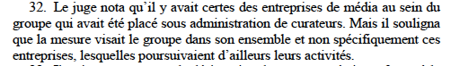
  - However, there is no such reason in the relevant part of the Ankara 6th Criminal Judgeship of Peace’s decision to reject the objection on 12 November 2015. As can be seen below, the allegation in the ECtHR decision is not included in the reason for the decision of the criminal judgeship of peace. It is stated that appointing trustees only to media companies is not contrary to Article 30 of the Constitution because the activities of media companies are continued by trustees. The ECtHR has not only refrained from writing in the decision this reason regarding Article 30 of the Constitution, but it has also produced a reason that was not present in the motivation of the decision and used it in its own decision (Annex 25, p. 7).
  - Since, for the same reason, one of the complaints regarding the freedom of the press is found inadmissible (see, § 99), this situation leads to the conclusion that the judgment has not been written with an impartial manner.
  - Although it is stated in the application form (§ 14) and Annex 1 (§ 23) and is an important fact regarding the violation of freedom of the press, the following facts are not included in the part of the ECtHR decision regarding facts:
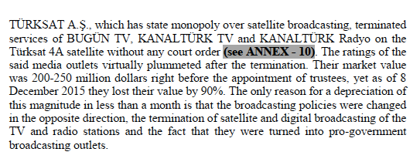
  - After this incident, the ratings of the media outlets in question fell to practically zero. The media outlets, whose market value was between 200-250 million dollars just before the appointment of trustees, lost 90% of their value as of 8.12.2015. As a result of this, on 1 March 2016, all the media outlets were completely closed by the trustees and their de facto existence was terminated.
  - The MASAK Report on 4 May 2016 is not included in paragraphs 37 and 38 of the ECtHR decision. On the other hand, the Applicant submitted to the ECtHR the full text of the report to the Court in English and the sections (16 pages) in Turkish showing that the accusations based on the trustee appointment decision are ill- founded (Annexes 32, 34, 35):
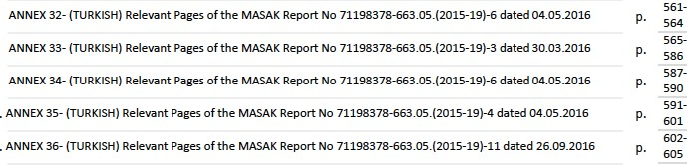
  - Although the ECtHR includes the first two MASAK (preliminary) reports against the Applicant in the section on facts (§§ 14-15), it does not refer to the MASAK Final Report on 4 May 2016, which shows that the allegations in the first two (provisional) reports are untrue. In fact, information in this report was given in detail in the application form and Annex 1 (Annex 1, §§ 26, 30-34), and the relevant pages (16 pages) were added as annexes in Turkish:
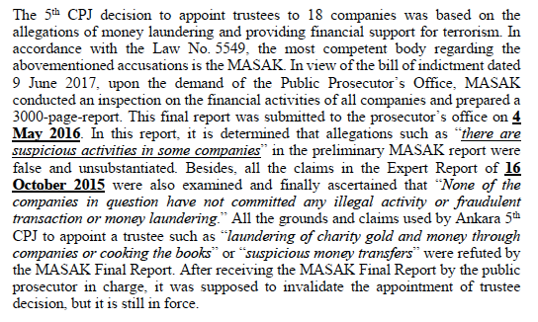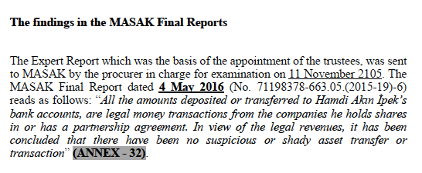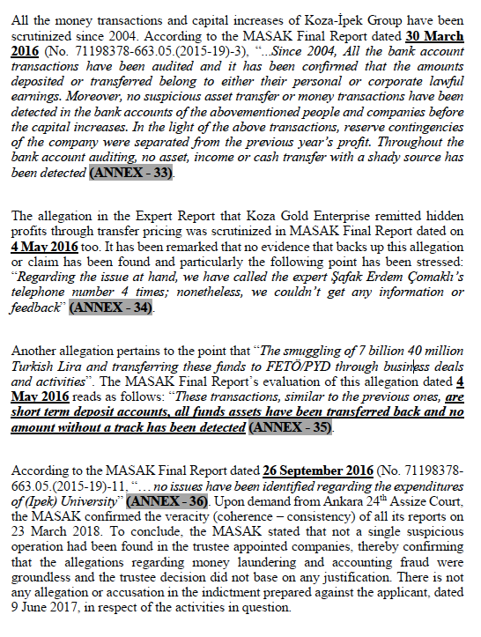
  - Despite this fact, the ECtHR omits the findings of the MASAK Final Report on 4 May 2016 in its decision and bases its decision of inadmissibility, inter alia, on the reason in paragraph 88: “l’intéressé n’en a fourni que de très bref extraits, parfois une seule phrase”.
  - It is unclear why the 16 pages (Annexes 32, 34, 35) are described as “très bref extraits, parfois une seule phrase” by the ECtHR. In addition, it was not determined only in the 2016 MASAK Final Report that the allegations made as a basis for the trustee appointment were untrue; none of the allegations were included in the indictment (it is not possible for an allegation that is not included in the indictment to constitute evidence of crime). Thus, it was already established with the indictment that the allegations in the trustee appointment decision were untrue and that the “strong suspicion of crime” condition foreseen in Article 133 of the CPP was not met (legal condition for appointment of trustee according to Art. 133 CCP: “existence of strong suspicion showing that the catalogued crimes have been committed within the activities of societies”). However, as explained above (§§ 16 and 19, above), the indictment is not included in the ECtHR decision, and both pieces of information are hidden from the public. If the MASAK Report dated 4 May 2016 and the indictment had been included in the ECtHR decision, it would have been understood from the decision that the complaint regarding the right to property could not be found inadmissible and accordingly the rejection of the complaint regarding the freedom of the press would not have been justified (§ 99).
  - In paragraph 40 of the ECtHR decision, it is stated that the office of prosecutor requested the confiscation of the companies in question and the reports established by the MASAK, SPK and VDK became the ground for the confiscation. First of all, the determinations in the reports by the SPK (Conseil des marchés financiers) and VDK (Conseil de contrôle de l’impôt) are not provided for in Article 133 of the CPP as catalogued crimes but are related to the capital market and tax law: It cannot constitute a legal basis for the appointment of trustees to companies. The report referred to as the MASAK report is the MASAK Final Report on 4 May 2016, and the accusations ascribed to the Applicant in the report and the Applicant’s answers, as stated in Annex 1 (see, Annex 1, §§ 52-60), are briefly as follows, yet they are not specified in the ECtHR decision. Donations made to two universities, an association, and a foundation before 2015 were shown as a crime and donations were considered a basis for the confiscation request:
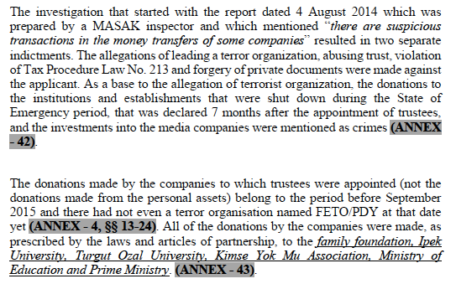
  - The ECtHR obscures the phrase “before 2015” in paragraph 40 of the decision. However, there was no terrorist organisation named “FETÖ/PDY” at that time. It was with the Court of Cassation decision on 26 September 2017 that established for the first time that the Gülen organisation was a terrorist organisation (see above). Membership or aid to a non-existent organisation is beyond reason. In its decision, the ECtHR also conceal where the donations were made: “two universities (one of which was founded by the Applicant), a family foundation, an association, the Ministry of Education and the Prime Ministry”. If the names of the institutions receiving the donations and the date of these donations (before 2015) were mentioned, no reader of the decision would believe that these acts were criminal offences when they were committed. No one would believe that the donations made by the Applicant to the family foundation for the construction of the university, which he founded under enactment of a law in 2011, would one day constitute a crime. There is no illegal aspect of the donations made to educational institutions before 2015. If the institutions and dates to which donations were made were specified in the decision, it would be understood that these donations are completely legal and that there is nothing illegal about making donations to universities, associations, and foundations, and it would be understood that there is no legal basis for the trustee appointments. It is unreasonable to claim that the foundation and university founded by the Applicant himself belonged to or were associated with “FETÖ/PDY” in 2011- 2015, because there was neither such organisation (FETÖ/PDY”) before 2015 nor a court decision. Both universities were established by law and FETÖ/PDY was not the legislator.
  - The Applicant’s money transfers to media organisations are also transfers made for investment purposes in order to make the media organisations the 3rd best media group in Turkey. Money transfers made by the Applicant from the companies of which he is the main shareholder to the media companies of which he is the boss are perfectly legal transfers. This fact has nothing to do with the crime of “supplying weapons to a terrorist organisation” (catalogue crime in Article 133 of the CPP); It is a completely legal activity. As it is stated in the ECtHR decision, “establishing a company to finance the educational institutions and media companies of a terrorist organisation” is counter intuitive. The organisation in question was not identified as a “terrorist organisation” before 2016 (see, above), the university was established by law in 2011 with the votes of AKP deputies, and the Gülen organisation and educational activities were openly supported by the AKP until the beginning of 2014. Did the ruling party support a terrorist organization? Therefore, if the Applicant’s version of the facts were included in the decision, it would be understood that the allegations are unfounded, and it would not be possible to make a decision of inadmissibility. In this regard, the Applicant made the following assessments in Annex 1:
  - For these reasons, the Applicant argued before the ECtHR that the principle of no punishment without law has been violated (see, “Griefs”, §§ 69-70). However, the ECtHR has decided, without any examination, that the case is inadmissible, thereby violating the right to a reasoned decision and its own case-law (Jean-Louis Magnin v. France).
  - The Applicant states the following in the conclusion of Annex 1 (para. 60):
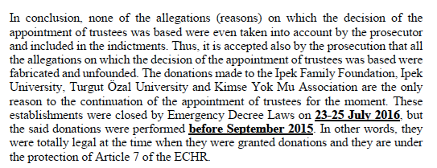
  - To conclude, the only charges against the trustee-appointed companies as a result of the investigation are: “donating before 2015 to two universities established by law, a family foundation and an association, and transferring money from companies belonging to the Applicant to the press organisations of which he was the owner for the purpose of investment” (all of them legal activities at the time when they were accomplished). Although the Applicant states this situation in detail in the application form and Annex 1 and shows that both charges (money laundering, aiding a terrorist organisation) in the reason of the trustee appointment decision on 26 October 2015 were untrue, none of these facts are included in the ECtHR decision, hence hidden from public. If the ECtHR had not believed the Applicant’s allegations, what it had to do was to communicate the case to the Government and ask whether the allegations were true; it was not supposed to render a decision of inadmissibility by concealing the Applicant’s version of the facts and violating his right to a reasoned decision.
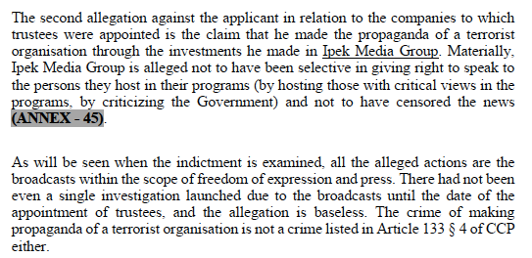
  - The allegations in paragraph 41 of the ECtHR decision have nothing to do with the application and are related to the capital market. Even if this claim were assumed to be true for a moment, there would be no such crime among the catalogue crimes listed in Article 133 of the CCP. Therefore, this crime cannot constitute a basis for trustee appointment, nor can it form a legal basis for interfering with the rights in the present case. However, since Article 133 of the CCP is not completely translated in the decision, it is impossible for the reader of the decision to understand this situation. While the ECtHR includes the facts in its decision which are unrelated to the application, it does not specify facts that would fundamentally affect the outcome of the decision and that are directly related to the result of the complaints.
  - Paragraph 43 of the ECtHR’s decision summarises the Applicant’s complaints in the application submitted to the Constitutional Court on 19 November 2015. However, the paragraph does not address the Applicant’s complaint regarding the violation of the principle of no punishment without law (see Annex 26, §§ 193-198). In addition, there was a coup attempt on July 15, 2016, and with the Decree Law No. 668 dated 27 July 2016, the media outlets were closed, and their assets were transferred to the Treasury without any compensation. A State of Emergency Commission was established with the Decree Law No. 685 dated 21 January 2017, but with the Prime Ministry Communiqué published on July 12, 2017, company shareholders or partners were expressly prohibited from applying to the State of Emergency Commission (see ECtHR Decision, §§ 67 and 69).
  - Since the Applicant did not have the right to apply to the State of Emergency Commission, he submitted a new petition to the Constitutional Court on 2 February 2018, containing new violations of rights arising from the closed media companies (Annex 29). In this new petition, the Applicant put forward the following new complaints: “Freedom of the press and right to property have been violated, as media outlets such as Bugün TV, Kanaltürk Television, Kanaltürk Radio, Millet Newspaper and Bugün Newspaper were closed with the Decree No. 668 and their assets (worth 225 million dollars) were transferred to the Treasury without any compensation. The presumption of innocence has been violated, as these media outlets were closed down by the Decree Law No. 668 without a court decision by being accused of membership in a terrorist organisation. The right of access to a court has been violated, as the right of the shareholders of the company to apply to the State of Emergency Commission and later to the administrative courts in matters of dissolution and confiscation of assets, is prohibited by Article 4 § 2 of the Prime Ministry Communiqué dated 12 July 2017 (see, Decision of the ECtHR, § 69).” (Annex 29). The Constitutional Court examined only one of these complaints (violation of freedom of the press due to the closure by decree), dismissed it (see ECtHR Decision, § 98), failed to examine the other complaints in its decision. Therefore, the Constitutional Court violated the right to a reasoned decision (Jean-Louis Magnin v. France).
  - However, these new violations of rights submitted by the Applicant to the Constitutional Court are not mentioned in the ECtHR decision, except for the one cited above. If, for example, the complaint regarding the right of access to a court had been specified and examined in the ECtHR decision, it would have been extremely difficult, perhaps impossible, to write the reason in the paragraphs 101-103 and rule for rejection. Also, the Applicant submitted these complaints to the ECtHR as he submitted to the Constitutional Court on 2 February 2018 and provided additional information on this matter in Annex 1 (Annex 1, § 29):
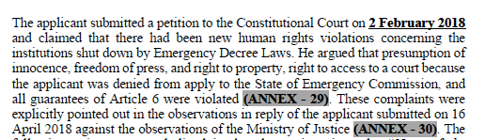
  - The Applicant reiterated the complaints mentioned in the above paragraph in the first pages of the observations in response dated 16 April 2018 to the Constitutional Court against the observations of the Ministry of Justice and he submitted these observations to the ECtHR too (Annex 31, p. 1-4). However, neither the ECtHR nor the Constitutional Court examined these complaints. They rejected these complaints (especially freedom of the press, right to property, right of access to a court and the principle of no punishment without law) without examining them. Since the Applicant’s complaints regarding the closure of media outlets by an Emergency Decree Law, valued at 225 million dollars, and the uncompensated transfer of his assets to the Treasury have not been examined by any court, including the ECtHR, there has been a clear denial of justice.
  - Paragraph 44 of the ECtHR decision includes the observations submitted by the Turkish Ministry of Justice to the Constitutional Court in 13 lines, whereas it refers to the Applicant’s observations in response in 3 lines and in an abstract language (§ 45). In fact, the Applicant also details the new complaints that emerged after the coup attempt in his observations in response. If these complaints had been included in the ECtHR decision, these complaints would have had to be examined and the reason for the rejections would become ill-founded. For example, if the violation of the right to access to a court had been examined, the grounds for rejection in their paragraphs 101-103 would have become unfounded. For example, if the violation of the right to property due to the closure of media companies under a decree and their transfer to the Treasury without compensation had been examined, both the description of “regulation of the use of property” (règlementer l’usage des biens) and the reason for the rejection would have become baseless with regard to the media companies. Interestingly, this complaint was also put forward openly in the ECtHR application form (p. 8), as it had been put forward before the Constitutional Court, but the ECtHR did not write and examine this complaint regarding the right to property in the decision, in violation of the right to a reasoned decision (Jean-Louis Magnin v. France):
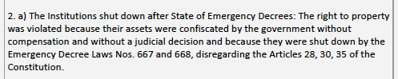
  - Paragraph 44 of the ECtHR decision states that the Government appointed trustees with the aim “to prevent the commission of new crimes” and therefore the intervention was legitimate. This justification is not included in the trustee appointment decision, and it is not stipulated in Article 133 of the CCP that a trustee can be appointed for such a purpose. Pursuant to Article 133 of the CCP, the appointment of a trustee is only possible for the purpose of “revealing the material truth”. The ECtHR does not state the Applicant’s views in its decision, omitting the fact that the media companies were completely closed and destroyed, and hiding from readers of the decision the argument that there is no legal basis for the interference with fundamental rights. In fact, any interference with fundamental rights without a legal basis constitutes a violation.
  - In the observations of the Ministry of Justice, submitted to the Constitutional Court, summarised in paragraph 44 of the ECtHR decision, it is stated that the intervention is temporary and related to the controlling of the use of property (règlementation de l’usage des biens). However, media companies worth $225 million were made to suffer losses and then closed de facto on 1 March 2016. Later, with the Decree Law No. 668, the legal existence of each was terminated and their assets were transferred to the Treasury without any compensation, and this issue was clearly put forward in the applicant’s observations in response (see, Annex 31, p. 1-4). In addition, the members of the Constitutional Court are well aware of this situation. For this reason, it is clear that the interference with the right to property should be considered as “deprivation of property”. However, the ECtHR does not specify in its decision what was stated in the Applicant’s observations in response dated 16 April 2018 (Annex 31) and in the application form (p. 9). If the following facts had been written in the ECtHR decision, it would have been difficult or even impossible for the ECtHR to characterise it as “réglementation de l’usage des biens” (see, Application form, p. 9):
  - These facts are not included in the ECtHR decision, and the most important argument that would affect the outcome of the decision is hidden from the public. If these facts had been stated in the decision, the interference with the right to property would not have been considered as a “reglementation de l’usage des biens”, at least for the media companies, because the companies in question (with a value of 225 million dollars) were actually closed on 1 March 2016 and their legal existence was terminated with the Decree Law No. 668 dated 27 July 2016 and their assets were transferred to the Treasury without compensation. With regards to the companies destroyed de facto and de jure without any court decision (de facto expropriation without any compensation), the intervention can be described as “deprivation of property”.
  - Paragraph 45 of the ECtHR decision refers to the MASAK Final Report on
4 May 2016 without specifying its content, and states that the Applicant claimed that the accusations regarding the trustee appointment in accordance with this report were unfounded. On the other hand, if the content of this report had been at least summarised in this paragraph, it would have been shown that the two accusations based on the trustee appointment were untrue, that the trustee decision was contrary to Article 133 of the CCP, and that the interference with the right to property and freedom of the press was unlawful (no legal basis). In fact, the Applicant brought this matter to the attention of the ECtHR in Annex 1 (Annex 1, § 29):
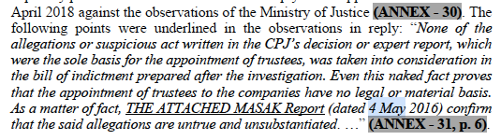
  - As can be seen from paragraph 44 of the ECtHR decision, the Ministry of Justice (Government) did not put forward an argument that the Applicant did not apply to the State of Emergency Commission. The Ministry is well aware that it is legally impossible for the Applicant to apply to the State of Emergency Commission (see, ECtHR Decision, §§ 67-69 and, Observations of the Turkish Ministry of Justice, Annex 30).
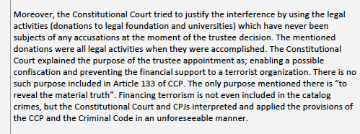
  - As can be clearly seen from paragraph 47 of the ECtHR decision, the Constitutional Court based the interference with the right to property (trustee appointment) on the aim “to prevent financing of terrorism and guaranteeing a potential confiscation”. However, trustees were appointed to 18 companies in the trustee appointment decision only on charges of “laundering money and aiding a terrorist organisation”. First of all, “aiding a terrorist organisation” is not among the catalogue crimes stipulated in Article 133 of the CCP. Secondly, since the Constitutional Court decided by inventing new crimes and reasons that were not stipulated in the law and in the decision of appointing trustee, the interference with the fundamental rights of the Applicant was devoid of legal basis. The crime of financing terrorism and aiding a terrorist organisation are different crimes, and neither crime is among the catalogue crimes stipulated in CCP article 133 (see, above). Money laundering crime is a catalogue crime (used for appointing trustees on 26 October 2015), and this accusation was not included in the indictment against the Applicant, and in the MASAK Final Report dated 4 May 2016, or the Constitutional Court decision. Therefore, this accusation upon which the trustee appointment decision was based turned out to be unfounded. In addition, there is only one purpose stipulated in Article 133 of the CCP, which is “revealing the material truth”. The purpose of “guaranteeing a possible confiscation” is in no way stipulated in Article 133 of the CPP. Although these explanations were submitted to the ECtHR by the Applicant and it was declared that there was no legal basis for the interference with the right to property and freedom of the press, the ECtHR has decided to reject the Applicant’s arguments without specifying or examining them in the decision (see, Application form, p. 8; Annex 1, § 40). TCC: Turkish Constitutional Court. CPJ: Criminal Peace Judgeships:
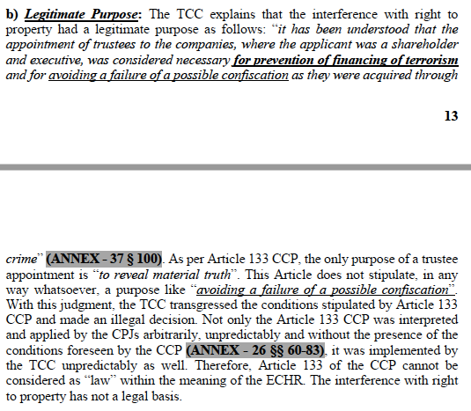
  - Paragraph 55 of the ECtHR decision refers to “existence of strong suspicion of crime” stated as reason in the Constitutional Court decision. Although, in the application form and its annexes he submitted to the Constitutional Court and particularly in his observations in response on 16 April 2018, the Applicant pointed out that the accusations (money laundering and aiding a terrorist organisation) which the Ankara 5th Criminal Judgeship of Peace put forward were not taken into account even in the indictment and the fact that they were untrue became apparent in the MASAK Final Report on 4 May 2016 (Annex 31, p. 6), the Constitutional Court, just like the ECtHR, rejected these facts without citing or examining them in its decision. As explained above, although these issues were clearly filed with the ECtHR, the ECtHR does not specify in its decision extremely important concrete evidence and arguments, such as the absence of a legal basis for the interference with the right to property and freedom of the press. If the ECtHR had expressed these views, it would have been revealed that there was no legal basis for the interference with fundamental rights and a decision of violation would have been made.
  - Paragraph 58 of the ECtHR decision also includes the Constitutional Court’s illegally formed reason. Accordingly, the Constitutional Court states that the appointment of a trustee was given “to prevent the commission of new crimes and guarantee the enforcement of a potential confiscation”. Neither of these purposes are specified in the trustee decision, nor is it stipulated in Article 133 of the CCP that a trustee can be appointed for these purposes. In short, although it is clear that the fundamental rights of the Applicant were interfered with by both the Criminal Judgeship of Peace and the Constitutional Court without any legal basis, and this situation was explained in the ECtHR application (see, above), the ECtHR has omitted these views of the Applicant in the decision, hid them from the public, and issued a decision of inadmissibility. Article 133 of the CCP stipulates that it is possible to appoint a trustee only “for the purpose of revealing the material truth” (= for the purpose of searching and obtaining evidence).
  - As can be understood from paragraphs 46-60 of the ECtHR decision, the violation of the right to property regarding the de facto and de jure termination of media companies was not separately examined and decided by the Constitutional Court. On the other hand, seizure, closure, and termination of media companies is prohibited by Article 30 of the Constitution. Therefore, media companies are under the express protection of the Constitution: Trustees cannot first be appointed to companies for their subsequent de facto and legal termination. By confiscating and terminating 2 TVs, 2 newspapers and a radio station (Turkey’s 3rd biggest media group before it was seized in 2015), which were worth $225 million, the right to property was violated with regard to these media companies in a way that was completely devoid of any legal basis, considering Article 30 of the Constitution. Although the Applicant explained this situation in the application form and in Annex 1, the ECtHR, like the Constitutional Court, has failed to specify Article 30 of the Constitution in its decision in any way and to examine the separately stated complaint about the right to property regarding the media companies (see above, Annex 1, §§ 16, 18, 39, 47):
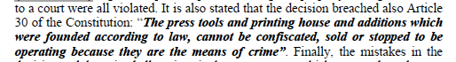
  - If Article 30 of the Constitution had been specified anywhere in the ECtHR decision, it would have been clear from the decision that the interference with the right to property and freedom of the press (regarding media companies) had no legal basis, and that the Constitution prohibited such interference, and the inadmissibility decision regarding these complaints would not have been made. If Article 30 of the Constitution had been specified, it would have been clear that there was no legal basis for appointing trustees to media companies, for destroying the editorial independence of television and newspapers by sacking more than 100 journalists and executives, and for closing these media outlets by an emergency decree law and confiscating their assets without any compensation. The ECtHR has made a ruling without specifying a very important constitutional provision that is decisive for the outcome of the main complaints (freedom of the press and right to property), thereby violating the right to a reasoned decision and hiding Article 30 of the Constitution from the public. Public scrutiny is the sole scrutiny of the ECtHR’s inadmissibility decisions since it is not possible to appeal against these decisions before the Grand Chamber.
  - While the ECtHR devotes five pages out of 19 to the Constitutional Court decision, it hardly includes the Applicant’s views on this decision. Interestingly, the Applicant dedicated 7 pages of the 20-page Annex titled “Additional Explanations” for the evaluation of the Constitutional Court decision (see Annex 1, p. 11-17). Moreover, as can be understood from the explanations above, the Applicant’s views clearly show that the reasons in the Constitutional Court’s decision and the interference with fundamental rights lack any legal basis. The ECtHR has violated the principle of adversarial proceedings and the right to a reasoned decision, since it issued a decision of inadmissibility without examining the applicant’s arguments brought against the reasons mentioned in the Constitutional Court decision. In fact, the views of the Applicant are decisive for the outcome of the case in many respects (Van de Hurk v. The Netherlands; Hiro Balani v. Spain).
  - Paragraph 62 of the ECtHR decision specify the reason for the Constitutional Court’s rejection of the violation of freedom of the press. According to this reason, “the appointment of trustees did not specifically target the media companies but all the companies of the group”. According to the Constitutional Court, complaints regarding freedom of the press were examined and dismissed under the right to property. The ECtHR, like the Constitutional Court, has rejected this complaint regarding freedom of the press for the same reason (see ECtHR Decision, § 99). On the other hand, this reason violates especially the principle of personality of criminal liability and shows that trustees were appointed to the media companies without satisfying the conditions provided for in Article 133 of the CPP.
  - The crimes committed by a person called “Mark” cannot be ascribed to his brother named “Matthew”, and crimes allegedly committed by a company operating in the mining field cannot be ascribed to companies operating in the media field. Each commercial company has a separate legal personality, and “Company B” cannot be held responsible for crimes allegedly committed by “Company A”. Therefore, even if it were assumed for a moment that companies operating in the mining sector committed crimes, media companies could not be held responsible for these crimes; the opposite is denial of the fact that each company is a separate legal person, hence violation of the principle of personality of criminal responsibility. In addition, since the media companies did not commit crimes, the conditions for appointment of trustees stipulated in Article 133 of the CCP were not fulfilled for the media companies. For this reason, there is no legal basis for appointing trustees to media companies, and both the freedom of the media and the right to property have been violated regarding these companies.
  - All these issues are clearly stated in the application form and its annexes submitted to the ECtHR (Annex 1, § 47):
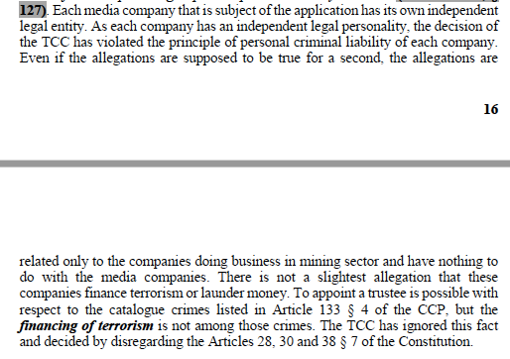
  - Since it has not stated these arguments in the decision, the ECtHR has rejected the applicant’s complaints with a motivation, without including the applicant’s arguments refuting the Constitutional Court’s reason, in obvious violation of the principle of personality of criminal liability (see, ECtHR Decision, § 99). If the arguments of the Applicant had been stated in the decision, it would have been seen that the reason in paragraph 99 was unfounded and the complaint might not have been rejected with the reason cited in paragraph 99 of the ECtHR decision.
  - It is not possible to consider that the judges of the ECtHR are not aware of the fact that each company has a separate legal personality or that they are unaware of the principle of personality of criminal liability, and it is incomprehensible that they have rejected a complaint regarding such an extremely important freedom as freedom of the press for the stated reason. Moreover, as explained in the application form, the Applicant’s companies were seized due to the media outlets ’dissenting publications, particularly after the corruption operations of 17-25 December 2013 (Annex 1, §§ 2, 3). The opposite is not true: Article 133 of the CPP came into force for the first time in June 2005 and was applied for the first time in the last 10 years (2005-2015) to the Applicant’s companies.
  - Paragraphs 63 and 64 of the ECtHR decision address the Constitutional Court’s reasons regarding the media outlets closed with the Decree Law No. 668. As stated in paragraphs 63 and 64 above, the Constitutional Court rejected the Applicant’s complaint that press freedom was violated due to the closing down of the media outlets after the coup attempt, on the grounds that no application was lodged with the State of Emergency Commission”.
  - On the other hand, paragraph 69 of the ECtHR decision states that the Applicant’s application to the State of Emergency Commission was prohibited by the Prime Ministry Communiqué dated 12 July 2017. According to Article 4 § 2 of this Communiqué, only legal representative (curators) of the closed institutions and organisations on the date of closure (27 July 2016) can apply to the State of Emergency Commission; Company shareholders cannot apply to this Commission. At the time of the closure, the legal representatives were the trustees, and in the Communiqué dated 12 July 2017 it was clearly stated that the shareholders of the company could not apply (see, ECtHR Decision, § 69):
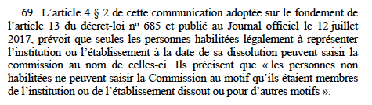
  - Precisely for this reason, the Applicant claimed before both the Constitutional Court and the ECtHR that his right to access to a court had been violated along with all the guarantees of Article 6 of the ECHR (Annex 1, § 29):
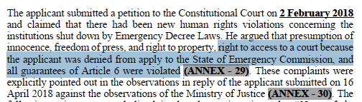
  - Despite this fact, neither the Constitutional Court nor the ECtHR have in their decisions mentioned the Applicant’s right to access to a court, nor have they examined and decided on this complaint. Both courts have failed to examine the violation of the right to access to a court, which is a prerequisite for other rights violations (right to property, freedom of the press), leading to a clear denial of justice in this regard. If the ECtHR had stated this complaint in its decision, it would have had to examine it. If it had done, it would have been difficult to write the reason stated in paragraphs 101-103, where the complaint about freedom of the press is rejected, and perhaps the decision of inadmissibility would not have been made. However, by hiding this complaint from the public, the ECtHR has rejected, with an unfounded reason, a complaint about freedom of the press, which is one of the indispensable elements for a democratic society (as if the Applicant was not prohibited from applying to the State of Emergency Commission, see, ECtHR Decision, § 69). Considering paragraph 69 of the ECtHR decision, the rejection of the complaint about freedom of the press on the grounds that domestic remedies were not exhausted is clearly unfounded since there was no remedy available to the Applicant in domestic law. Despite Article 4 § 2 of the Prime Ministry’s Communiqué dated 12 July 2017, if the State of Emergency Commission remedy had been an effective and open remedy for the Applicant, this could have been found out just by asking to the Government to demonstrate that it was effective. It is the Government’s responsibility to demonstrate that a domestic remedy prohibited by law for the Applicant is effective in practice. The burden of proof in this matter does not belong to the Applicant because, with its Communiqué, the Government prohibited expressly the Applicant from lodging an application with the State of Emergency Commission. Therefore, the rejection of the complaint on the grounds that no application was made to the State of Emergency Commission could only be possible after the Government’s response has been received and the Government has proved that this remedy was effective. Therefore, the reason in the ECtHR decision (§§ 101-103) cannot be stated without the application being communicated to the Government because the Prime Ministry Communiqué issued by the Government prohibits company partners and shareholders (the Applicant) to apply to the State of Emergency Commission. For a domestic remedy to be considered effective, first of all, making a legal application must be accessible to the Applicant. In the present case, the Applicant’s application to the State of Emergency Commission was prohibited by law. The Committee, which is composed of 3 judges, has decided by changing the well-established case-law of the ECtHR, and it is not possible for a Committee to change the well-established case-law of the ECtHR. Only applications to be rejected without further review may be rejected by a Committee. Hamdi Akin Ipek v. The Turkey decision infringes therefore Article 28 of the ECHR.
  - According to the ECtHR, applicants are only obliged to exhaust domestic remedies which are available in theory and in practice at the relevant time and which they can directly institute themselves – that is to say, remedies that are accessible, capable of providing redress in respect of their complaints and offering reasonable prospects of success (Sejdovic v. Italy [GC], § 46; Paksas v. Lithuania [GC], § 75).
  - The Committee has overturned this well-established case-law of the Grand Chamber of the ECtHR, and this change in the case-law is not within the competence of a Committee. Therefore, paragraphs 101-103 of the ECtHR’s Hamdi Akın İpek v. Turkey decision violates Article 28 of the Convention.

Conclusion

  - Our conclusion is that the “Facts” in the ECtHR’s Hamdi Akın İpek v. Turkey decision seem to be purposefully selected and written to make a decision of inadmissibility, as stated above. Our assessment is that many facts, arguments, legal judgments and complaints, which are stated by the Applicant, and which are crucial and decisive for the result of the complaints, are not included in the decision.

    - RELEVANT DOMESTIC LAW (Droit interne pertinent) (§§ 64-69)

  - With regard to the application, appointment of trustees to media companies, dismissal of more than 100 journalists and executives, their removal from satellite, their de facto closure on 1 March 2016, legal closure on 27 July 2016, and transfer of their assets (225 million dollars) to the Treasury without compensation are in violation of Article 30 of the Constitution, and all these interferences (freedom of the press and the right to property) are devoid of any legal basis especially for this reason. Although the Applicant based his claims on Article 30 of the Constitution many times, the ECtHR does not refer to Article 30 of the Constitution in its decision. If this provision had been stated in the decision, it would have been clearly seen that the interference with the freedom of the press and the right to property with respect to the media companies had no legal basis and that these rights were violated.

Article 30 of the Turkish Constitution:
Article 30 – “A printing house and its annexes, duly established as a press enterprise under law, and press equipment shall not be seized, confiscated, or barred from operation on the grounds of having been used in a crime.” (EN)
Article 30 – « Les imprimeries et leurs dépendances, ainsi que leurs moyens de presse, créées en tant qu'entreprises de presse d'une manière conforme à la loi ne peuvent être saisis ou confisqués ni interdits d'exploitation, sous le prétexte qu'ils constituent l'instrument d'un délit ». (FR)
  - Article 133 of the CCP is not completely mentioned in the decision of the ECtHR, and only a brief summary is included. Interestingly, this provision is the basis of the interferences to fundamental rights in the present case, and the main argument of the Applicant is that the interferences against the freedom of the press and the right to property were performed in violation of Article 133 of the CCP and lacked a legal basis. For this reason, CCP article 133 should have been cited in the decision. Article 133 of the CPP is as follows:

2. Article 133 of the Turkish Code of Criminal Procedure as in force at the material time (on 26 October 2015):
“Article 133 - (1) In cases where there are strong grounds of suspicion that the crime is being committed within the activities of a firm and it is necessary for revealing the factual truth, the judge or the court is entitled to appoint a trustee for the administration of the firm with the aim of running the business of the firm, for the duration of an investigation or prosecution. The decision of appointment shall clearly indicate that the validity of the decisions and interactions conducted by the organ of the administration depends upon the approval of the trustee, or that the powers of the organ of the administration has been transferred to the trustee. The decision on appointing the trustee shall be announced by the newspaper for the record of the trade and by other suitable means.
- Fees for the trustee estimated by the judge or the court, shall be compensated by the budget of the firm. However, in cases where there is a decision on no ground for prosecution has been rendered about the investigated crime, or if there is a judgment of acquittal, the total sum of money paid as the fee of the trustee shall be compensated by the state treasury, with interest.
- The related persons are entitled to apply to the competent court against the interactions of the trustee, according to the provisions of the Turkish Civil Code dated 22.11.2001, No. 4721 and of the Turkish Commerce Code dated 29.6.1956, No. 6762.
- The provisions of this article are applicable only for the following crimes as listed below:
- Crimes regulated in the Turkish Criminal Code,
- Smuggling migrants and human trafficking (Arts. 79, 80),
- Producing and trading in narcotic or stimulating substances (Art. 188),
- Forgery in money (Art. 197),
- Prostitution (Art. 227),
- Providing place and opportunity for gambling (Art. 228),
- Embezzlement (Art. 247),
- Laundering of assets emanating from crime (Art. 282),
- Armed organization (Art. 314), or providing arms for such organizations (Art. 315),
- Crimes against the secrets of the state and spying (Arts. 328, 329, 330, 331, 333, 334, 335, 336, 337),
- Smuggling weapons as defined in the Act on Fire Arms and Knives as well as Other Tools (Art. 12),
- Embezzlement as defined in Banking Act Art. 22, subparagraphs (3) and (4),
- Crimes as defined in Combating Smuggling Act that require the punishment of imprisonment,
- Crimes as defined in the Act on Protection of Cultural and Natural Substances, Arts. 68 and 74.”

  - COMPLAINTS

- Although the Applicant raised all of the following complaints before the Constitutional Court, they have not been examined in any way by the ECtHR, nor have they been mentioned in the application form:
  - “The Institutions shut down after State of Emergency Decrees: The right to property was violated because their assets were confiscated by the government without compensation and without a judicial decision and because they were shut down by the Emergency Decree Laws Nos. 667 and 668, disregarding the Articles 28, 30, 35 of the Constitution.
  - Finally, before the verdict on merits, a hotel, a university, media outlets, movable assets, luxury vehicles and a plane which belong to the applicant were sold or transferred to third parties. This situation shows that the real purpose is to seize the assets without returning them, a de facto expropriation.”
  - “The applicant, as a shareholder, does not have the right to apply to the State of Emergency Commission and later to the courts, the right to access to a court was violated.”
  - “The right to a reasoned decision was violated because … the Turkish Constitutional Court rendered its decision without examining many arguments (complaints) of the applicant which were clearly asserted in the
application form and in the additional petition dated 2.2.2018, and which affect directly the result of the proceedings (Jean-Louis Magnin v. France).”
(The Constitutional Court dismissed the applicant’s four complaints without any examination at all although he invoked expressly before it, see §§ 47-48 above).
  - Continuation of trustee is based on the legal activities (donations to two legal universities, a legal foundation, and a legal association) for more than 3 years. The institutions which were made donations, were announced to have relationship with a terror organization by Decree Laws published after 15 July 2016 but they were totally legal at the time of donations (before September 2015). The legislation in force at the time of their commissions had not prohibited the said donations to these institutions. The fact of continuation of trustee appointment based on these legal activities when they were accomplished violate the principle of no punishment without law.” (see, Yasin Özdemir v. Turkey, no. 14606/18, 7 December 2021).
The Applicant openly raised this complaint before both the Constitutional Court (Annex 26, § 193-198) and the ECtHR: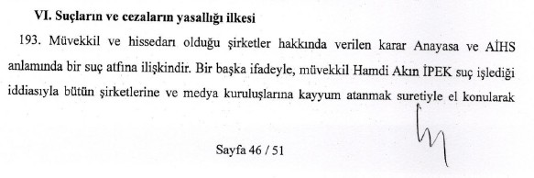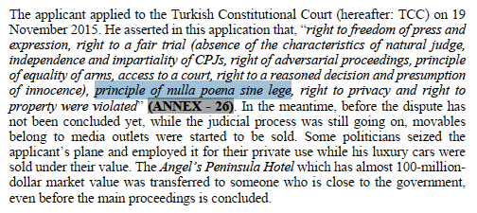
  - The media outlets, foundation and university were announced as criminals (by the Emergency Decree Law no: 668) without a judicial decision. For this reason, the presumption of innocence (of these legal entities) was violated. (Compare, Application form, p. 8-9 and Decision of the ECtHR, §§ 70-104).
The Applicant also openly filed this complaint regarding the presumption of innocence before the Constitutional Court (see, § 48 above, Annex 29, p. 2), and since the complaint originated from a statutory decree (legal norm), there is no other domestic remedy in domestic law other than the Constitutional Court.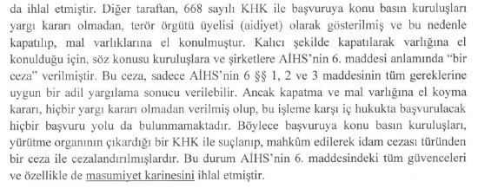
    - By omitting or failing to examine the above complaints in its decision in any way, the ECtHR has made a ruling in violation of its own case-law and has violated the Applicant’s right to a reasoned decision.
    - According to the ECtHR, « il reste que les tribunaux ne peuvent être dispensés d’examiner dûment et de répondre aux « principaux moyens » dont ils sont saisis (arrêt Wagner et J.M.W.L. précité, § 96 in fine). Si, de surcroît, ces moyens ont trait aux « droits et libertés » garantis par la Convention ou ses Protocoles, les juridictions nationales sont astreintes à les examiner avec une rigueur et un soin particulier (ibidem). ... La Cour a de plus déjà eu l’occasion de souligner que la motivation a notamment pour finalité de démontrer aux parties qu’elles ont été entendues et, ainsi, de contribuer à une meilleure acceptation de la décision (voir, mutatis 38 mutandis, Taxquet c. Belgique [GC], no 926/05, CEDH 2010, 16 novembre 2010, § 91).” (Jean- Louis Magnin v. France, no. 26219/08, 10 May 2012, § 29).

ASSESSMENTS BASED ON THE LAW (EN DROIT)

    - Violation of Presumption of Innocence (§§ 70-73)

    - The Applicant put forward the following complaints in the application form:
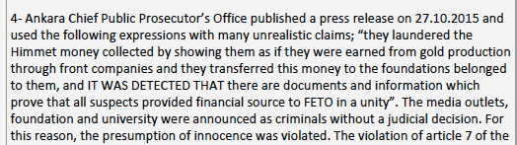
    - The Applicant has two separate complaints regarding the presumption of innocence. The first is the allegation that the presumption of innocence was violated when the media outlets (two TVs, two newspapers and a radio station) as well as the foundation and university founded by the Applicant were declared members of a terrorist organisation with the Emergency Decree Law no. 668. A detailed explanation is given in the application form and annexes regarding this complaint, and the application form says, “The media outlets, foundation and university were announced as criminals without a judicial decision”.
    - The ECtHR neither includes nor examines this complaint in its decision: the ECtHR has violated its own jurisprudence since it ruled, without examining it in any way, by violating its own case-law, the right to a reasoned decision (Jean-Louis Magnin v. France, no. 26219/08, 10 May 2012, § 29).
    - Secondly, the Applicant claimed that the incriminating statement in the press release of the Ankara Office of Chief Public Prosecutor violated the presumption of innocence. He submitted a translation of this statement to the ECtHR, which is as follows: “They laundered the Himmet money collected by showing them as if they were earned from gold production through front companies and they transferred this money to the foundations belonged to them, and IT WAS DETECTED THAT there are documents and information which prove that all suspects provided financial source to FETO in a unity”.
    - Regardless of its name, providing financial resources to a terrorist organisation is a crime under the Turkish Penal Code.
    - The Applicant claimed that the above statement violated the presumption of innocence. The ECtHR has made a decision without referring to the statement in its decision, without revealing to the public what the Applicant was complaining about, and by hiding from public scrutiny whether the above statement violated the presumption of innocence. If the statement that is the subject of the complaint had been included in the decision, it would have been understood that the Office of the public prosecutor did not restrict itself to informing the public about the investigation. The ECtHR rules for inadmissibility by stating that the office of prosecutor referred to the expert’s report. Even if this statement is mentioned in the expert report, is it not a violation of the presumption of innocence that the office of prosecutor cited the expert report verbatim? The fact that the Applicant’s name is not mentioned directly does not change the result either. All of Turkish people are well aware that the first person referred to in the press release is media mogul Hamdi Akın Ipek. It cannot be understood why the ECtHR has made a decision without referring to the statement complained of by the Applicant. If the statement in question had been included in the decision, perhaps the complaint would not have been rejected on the grounds that it was manifestly ill-founded.

    - Violation of the Right to Property (§§ 74-97)

    - Two separate complaints were brought before the ECtHR regarding the right to property:
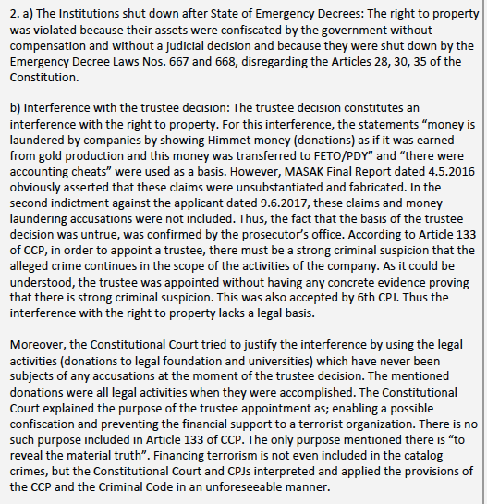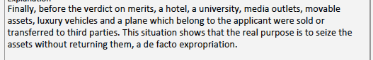
    - As can be understood from the explanations above, the Applicant first lodged a complaint with the ECtHR regarding the fact that the media outlets (worth 225 million dollars) were closed with the Decree Law No. 668 and transferred to the Treasury without any court decision. Regarding this complaint, it was stated above that the Applicant’s right to apply to the State of Emergency Commission was prohibited in domestic law but he lodged a complaint with the Constitutional Court, and the Constitutional Court rejected the application without examining the complaint (see §§ 47-49, 56, 69, 71, above). The Applicant also claimed that freedom of the press was violated for the same reason, and the ECtHR, like the Constitutional Court, has rejected this complaint with unfounded reasons (§§ 101-103). Therefore, the complaint about the right to property on this issue should not be confused with the complaint about the freedom of the press.
    - The ECtHR, like the Constitutional Court, has rejected the application without specifying the Applicant’s first complaint about the right to property (which concerns the fact that the Decree Law no. 668 shutting down two TVs, two newspapers and a radio station and transferring his assets to the treasury without compensation) and without examining this complaint. Thus, a clear denial of justice has emerged, and the ECtHR has violated the right to a reasoned decision, in violation of its own case-law (Jean-Louis Magnin v. France, No: 26219/08, 10 May 2012, § 29).
    - Secondly, regarding the right to property, the Applicant only made the following complaint: trustees were appointed to 18 companies in 2015, the trustee appointment decision was in contradiction with Article 133 of the CCP, and this decision was made without satisfying the conditions set up in Article 133 of the CPP. In fact, none of the conditions in the law were met: the fact that there was no strong suspicion of crime was established by the indictment and the 2016 MASAK Final Report: trustees were appointed without a strong suspicion of crime. The crime of aiding a terrorist organisation and financing of terrorism were not among the catalogue crimes stipulated in Article 133 of the CCP; however, the peace judge and the Constitutional Court gave decisions based on these crimes. The purpose of “preventing the commission of new crimes and guaranteeing the enforcement of a potential confiscation” is not envisaged in Article 133 of the CCP. The sole purpose set up in Article 133 of the CPP is to “reveal the material truth”, and the judicial decisions and the Constitutional Court’s decision are based on purposes not included in article 133 of the CPP. For these reasons, the trustee appointment decision was given in clear violation of Article 133 of the CCP, and the interference with the right to property with the trustee appointment decision lacks a legal basis. The property right has been violated because the decision lacks legal basis. Briefly, in the application form of the ECtHR, the Applicant alleges that this right has been violated only because of “interference with the right to property without any legal basis”.
    - The ECtHR, on the other hand, writes some of the complaints indicated in the application form, but does not specify the underlying facts in its decision (see, above). For example, the Applicant stated the arguments why Article 133 of the CPP was not a foreseeable provision, but these arguments and concrete facts invoked by the applicant are not specified in the decision. In addition, the ECtHR decides to examine the complaints raised with regard to Articles 6 and 7 of the ECHR under the title of right to property, but it does not specify many concrete complaints of the Applicant regarding these articles (see, below). Finally, as the complaints in the application form are not properly stated in the decision, the ECtHR invents new allegations that the Applicant did not put forward and writes reasons for them (compare with § 86 above). The following complaints, which are important and decisive for the outcome of the application, are not mentioned in any way in the ECtHR decision:
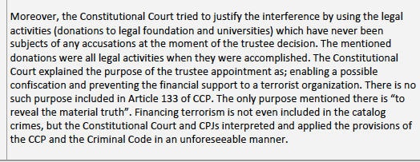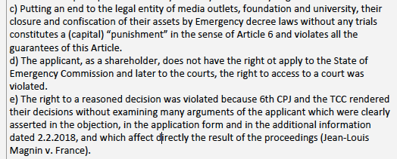
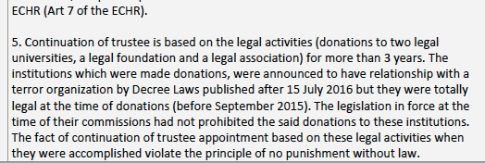
    - With regard to the complaints in the petition of objection above, the ECtHR addresses only the one about the fact that his right to a reasoned decision was violated when the 6th criminal peace judge issued a decision of rejection without responding to the arguments; however, the ECtHR does not mention or examine the Applicant’s complaint that the Constitutional Court violated his right to a reasoned decision (see also, § 77 above).
    - The ECtHR states the complaints as follows, and while it does not write many of the Applicant’s important complaints in its decision, it also creates some complaints and writes reasons for them (complaints in turquoise are not available in the ECtHR application form):
- Le requérant se plaint du placement de son groupe sous administration d’un curateur sur décision d’un juge de paix. Il allègue que les juges de paix ne constituent pas des autorités judiciaires conformes aux exigences de l’article 6 de la Convention et qu’ils ne sont pas indépendants et impartiaux. Il soutient que la base légale de la mesure ne répondrait pas aux exigences de la Convention en cela qu’elle ne serait pas suffisamment prévisible. Selon lui, les conditions d’une telle mesure ne seraient pas réunies puisqu’il n’y aurait pas de soupçons suffisamment forts. D’ailleurs, le fait que la mesure visait également à permettre de recueillir des preuves démontrerait le caractère insuffisant de celles sur lesquelles elle se fondait. En outre, il estime que le président du groupe d’experts ne disposait pas des qualités de bonne moralité requises pour exercer cette mission et que ses déclarations visant le mouvement Gülen sur les réseaux sociaux compromettrait son impartialité. Il affirme par ailleurs qu’un rapport du MASAK de 2016 (voir paragraphe Erreur ! Source du renvoi introuvable. ci-dessus) indiquerait que les accusations étaient infondées. En tout état de cause, il estime qu’il aurait été possible d’opter pour une mesure moins attentatoire à ses droits en nommant, par exemple, pour chaque société, un curateur de contrôle, chargé d’approuver les décisions de la direction, plutôt que de nommer un curateur chargé d’administrer la société en lieu et place de la direction.
- Il se plaint en outre de ce que les rapports ne lui aient pas été communiqués avant l’adoption de la mesure litigieuse, que les curateurs aient pris leurs fonctions plusieurs jours avant la publication de la mesure dans le journal du registre du commerce ainsi que de ne pas avoir été associé à la sélection des derniers.
- Le requérant soutient également que les décisions des juges de paix étaient insuffisamment motivées.
- Il invoque à l’appui de ses griefs les articles 6 et 7 de la Convention ainsi que l’article 1 du Protocole no 1. » (Decision of the ECtHR, §§ 74-77).

    - It is unclear why the ECtHR does not specify the complaints that are decisive for the outcome of the case in its decision but creates some complaints and writes long reasons for them (see, §§ 85, 91, 92 of the Decision). The ECtHR has the authority to (re)qualify facts and complaints; however, it does not have the authority not to write, specify or hide from the public the main complaints and the facts and arguments on which these complaints are based.
    - Paragraph 81 of the ECtHR decision qualifies the interference with the right to property as “réglementer l’usage des biens”. This conclusion becomes a possibility because the court does not write many facts in its decision that the Applicant clearly stated. If, on the other hand, the following facts had been written in the decision, it would not have been possible to make the same qualification, at least for media companies, and it would have been necessary to make a qualification of “deprivation of property”:
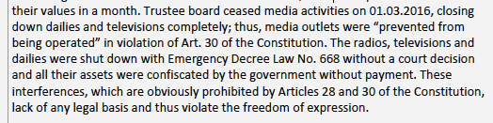
    - Paragraph 82 of the ECtHR decision skips, without any examination, the most important issue in terms of the Applicant’s complaints. The Applicant claimed that the interference with the right to property (appointing trustees) was devoid of legal basis and devoted all his complaints to this issue (see §§ 89-90 above). On the other hand, the ECtHR does not examine the most crucial complaint in any way: it only refers to Article 133 of the CCP and states that there was a legal basis for the interference, which it does, without stating the arguments of the Applicant on this issue and the facts on which it was based. In fact, the Applicant claimed that trustees were appointed and kept in their posts without satisfying the conditions set up in Article 133 of the CPP, without strong suspicion of crime, without relying on catalogue crimes, and without showing a legitimate purpose, and argued that Article 133 of the CPP was applied as an unforeseeable manner. He noted that the interference with the right to property was devoid of legal basis, since the trustee appointment decision was made in violation of Article 133 of the CCP, and therefore he claimed that this right was violated. In addition, the Applicant argued that seizing media companies by appointing trustees, closing de facto them on 1 March 2016 and confiscating their assets without compensation on 27 July 2016 by an Emergency Decree Law are clearly contrary to Article 30 of the Constitution, and therefore destroying of media companies lacks a legal basis. Despite this fact, the ECtHR has never written Article 30 of the Constitution in its decision, has never examined these allegations and whether there was a legal basis for the interference, based on arguments and facts.
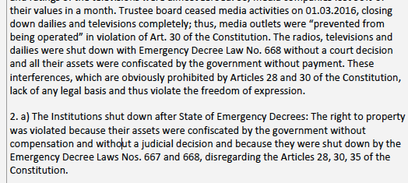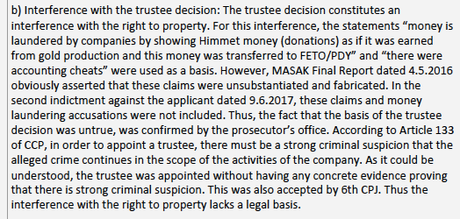
    - If the ECtHR had had Article 133 of the CCP translated and had included it in its decision and had examined whether the conditions in this Article had been met in the present case and whether it had been in compliance with Article 30 of the Constitution, it would have been understood that the interference with the right to property was devoid of legal basis and a decision of inadmissibility would not have been given.
    - The ECtHR also lists three legitimate purposes in paragraph 82: “to prevent the commission of new crimes, to facilitate the administration of evidence and to guarantee the enforcement of a potential confiscation”. However, these purposes are not foreseen in Article 133 of the CCP. Neither the national courts nor the ECtHR can rely on purposes not stipulated in domestic law as legitimate purposes; otherwise, it makes the interference illegal (lack of legal basis). In Article 133 of the CPP, only the purpose of “revealing the material truth” is foreseen as legitimate aim. Since Article 133 of the CPP is not stated verbatim in the ECtHR decision, this important error is also hidden from the public. If it had been written and examined in the decision that the sole purpose foreseen in Article 133 is to “revealing the material truth”, it would have been seen that the reasoning in the Constitutional Court’s decision (preventing new crimes and guaranteeing a potential confiscation) was unlawful and therefore the interference was devoid of legal basis. For this reason, the ECtHR decision includes crucial errors too.
    - Paragraph 83 of the ECtHR decision notes that the Applicant’s arguments have been carefully examined by the criminal judgeship of peace and the Constitutional Court. This argument is untrue and, as explained above, the Constitutional Court in particular rejected the Applicant’s five separate human rights complaints without examining them in any way (see, §§ 77-79, above). Like the ECtHR, the Constitutional Court also relied on unlawful reasons (such as “financing of terrorism, preventing commission of new crimes, enabling a possible confiscation”) that were not foreseen in Article 133 of the CCP, and although these issues were also brought forward before the ECtHR, the ECtHR has made the following assessment in its decision. “… les arguments que le requérant a soulevés ont été soigneusement examinés par les juridictions nationales, dont la Cour constitutionnelle, qui ont apportés des réponses motivées”. Although the Applicant showed in 7 pages that the decision of the Constitutional Court was against the law and the Constitution (Annex 1, p. 11-17), the ECtHR has managed to write the reason in question without examining any of these arguments. Although the Applicant claimed that Article 30 of the Constitution was clearly violated in the present case, like the ECtHR, the Constitutional Court did not even refer to this article in its decision and dismissed many complaints without examining them. Despite all this, it is unfounded to write the reason that “the Constitutional Court carefully (soigneusement) examined the arguments of the Applicant”.
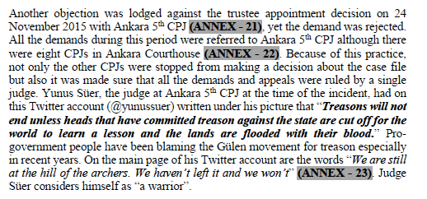
    - Paragraph 84 of the decision rejects the Applicant’s complaint that the criminal judgeships of peace are not independent and impartial, relying on Baş v. Turkey judgment (§§ 269-281). In fact, the application form refers to specific and concrete facts directly showing that the judge who took the trustee decision was not impartial; these facts were not examined in Baş v. Turkey judgment (§§ 269-281). Yet the ECtHR omits these facts in its decision, hides them and rejects them. Recep Tayyip Erdogan, who was the Prime Minister at the material time, was behind the seizure of the Applicant’s 18 companies. The Applicant was accused of aiding the Gülen organisation and therefore his companies were seized. The Gülen organisation was accused by members of the government of “betraying” the ruling party (AKP) after the corruption operations on 17-25 December 2013. The Ankara 5th Criminal Judge of Peace, Yunus Süer, who appointed trustees to 18 companies and made many subsequent decisions in the instant case, shared the following posts on his Twitter account:
    - The application form and Annex 1 also include the following concrete facts:
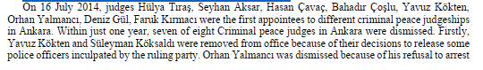
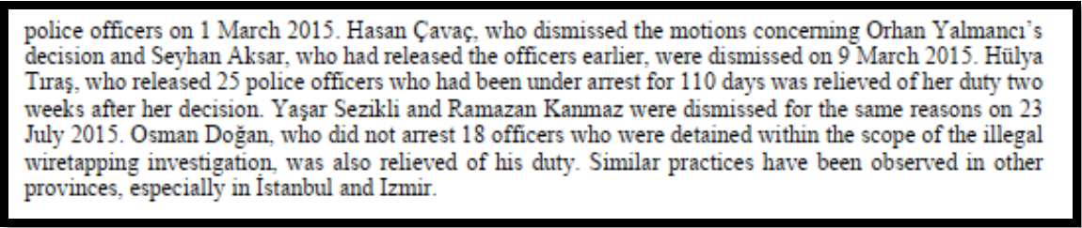
    - None of these facts are addressed and concretely examined in the Baş v. Turkey decision (see Baş v. Turkey, §§ 269-281). If these facts, and especially the Tweets of Ankara 5th Criminal Peace Judge, Yunus Süer, who made the trustee appointment decision on 26 October 2015, had been mentioned and examined in the decision, it would have at least been ruled that the judge was not impartial, and it would have been difficult to make a decision of inadmissibility. The ECtHR has rejected the related complaint without mentioning the extremely important concrete facts in the decision that are decisive for the outcome of the complaint.
    - The Applicant did not put forward the complaint (in his application form) mentioned in paragraph 85 of the ECtHR decision. Therefore, the reason regarding this complaint is also irrelevant.
    - Paragraph 87 of the ECtHR decision makes evaluations about strong suspicion of crime, but the evaluations are about “sufficient suspicion” (preuve suffisante, soupçons suffisants) instead of “strong suspicion of crime”. Article 133 of the CPP stipulates that a trustee can be appointed only if there is “strong suspicion of crime” (de forts soupçons). The law provides that a trustee cannot be appointed with sufficient suspicion. Therefore, at the stage of investigating whether there is a legal basis for the interference, the ECtHR cannot conduct investigation for sufficient suspicion, because domestic law stipulates “existence of strong suspicion of guilt” (existence de forts soupçons quant à la commission de l’infraction reprochée). The ECtHR states in this paragraph that the criminal judgeship of peace did not engage in any arbitrary practice. However, the Ankara 5th Criminal Judgeship of Peace decided to appoint a trustee based on the crimes of “money laundering (Art 282 of the Turkish Penal Code - TPC) and aiding a terrorist organisation (Art 220 § 7 of the TPC)”, and Article 220 § 7 of the TPC is not among the catalogue crimes listed in Article 133 of the CPP. The catalogue crimes include crimes of “terrorist organisation and supplying weapons to the organisation” (Articles 314 and 315 of the TPC). In the decision of the Constitutional Court, it is written that a trustee was appointed for the crime of “preventing financing of terrorism” (see, § 16, above). Preventing financing of terrorism is stipulated in Law No. 6415 dated 7 February 2013, and this crime is not among the catalogue crimes listed in Article 133 of the CCP. Appointing a trustee based on crimes that are not in the law is purely arbitrary practice. Moreover, the accusations of aiding a terrorist organisation and money laundering were not included in the indictment brought later (in 2017), and although the Applicant submitted it (Annex 39), the ECtHR does not include the content of this indictment (see, § 16, above). Although these issues are explained as follows in Annex 1, they are not included in the ECtHR decision (Annex 1, para. 52):
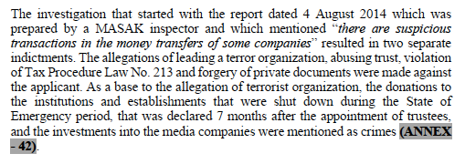
    - To summarise, although the Applicant showed in Annex 1 that the
indictment and the MASAK Final Report on 4 May 2016 revealed that the crimes based on the trustee appointment decision were not committed, the ECtHR has ruled, without taking these facts (the indictment and the MASAK Final Report) into account, that there was “sufficient suspicion” and that there was no arbitrariness.
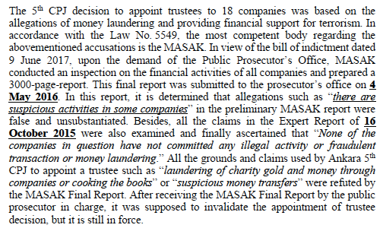
    - The application form does not cover the complaints mentioned in paragraphs 91 and 92 of the ECtHR decision; the Applicant lodged no such complaints (compare §§ 8-9 of the Application form and §§ 91-92 of the Decision of the ECtHR).
    - With regard to the decision to keep trustees, which has been continuing for 7 years, the ECtHR rules in paragraph 95 of the decision that this period of time is reasonable. The sole purpose of the appointment of trustees in Article 133 of the CPP is to “reveal the material truth”. To put it differently, the purpose is to investigate whether the crimes committed within the framework of the company’s activities continue to be committed; it is to obtain evidence. To date, government agents have not engaged in any activity such as obtaining criminal evidence in order to reveal the material truth in the companies: they only changed the publishing policies of the media outlets they seized and had these organisations shut down after 5 months. Investigation of criminal evidence within the framework of a company’s activities takes a maximum of 6 months. It could take a year or two at most. Moreover, a purpose such as search for evidence of crime has never been served until now. Considering 7 years as reasonable for a temporary measure is also contrary to the decisions of the ECtHR, because even a period of 3 years in a single degree trial may violate the right to be tried within a reasonable time (Article 6 of the ECHR). Moreover, the indictment was prepared in 2017 and it could be brought only on charges of “making donations to two universities, a foundation and an association, and transferring funds for investment purposes to the media outlets of which the Applicant is the owner”. No accusations were made apart from these. Because the temporary measure should have been terminated with the preparation of the indictment at the latest, it does not seem reasonable to consider the continuation of the temporary measure for 7 years.

    - Violation of Freedom of the Press (§§ 98-104)

    - The Applicant submitted the following complaints regarding freedom of the press:
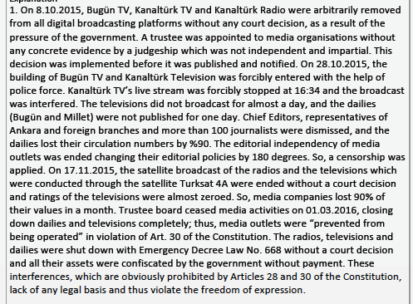
    - The ECtHR has only examined the following complaints:
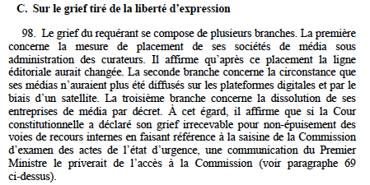
    - A comparison of the Applicant’s complaints and the ECtHR’s statements shows that many of the Applicant’s complaints regarding freedom of the press have not been examined in any way by the ECtHR:
“On 28.10.2015, the building of Bugün TV and Kanaltürk Television was forcibly entered with the help of police force. Kanaltürk TV’s live stream was forcibly stopped at 16:34 and the broadcast was interfered. The televisions did not broadcast for almost a day, and the dailies (Bugün and Millet) were not published for one day. Chief Editors, representatives of Ankara and foreign branches and more than 100 journalists were dismissed, and the dailies lost their circulation numbers by %90. … So, a censorship was applied. … So, media companies lost 90% of their values in a month. Trustee board ceased media activities on 01.03.2016, closing down dailies and televisions completely; thus, media outlets were “prevented from being operated” in violation of Art. 30 of the Constitution. … These interferences, which are obviously prohibited by Articles 28 and 30 of the Constitution, lack of any legal basis and thus violate the freedom of expression.”
    - If these facts and complaints had been written and examined in the ECtHR decision, it would have been almost impossible to make a decision of inadmissibility. However, the ECtHR has rejected the application without specifying in its decision the extremely important facts and complaints above regarding the freedom of the press, which is among the sine qua non conditions of a democratic society.
    - Paragraph 99 of the ECtHR judgment rejects one of the complaints made by the Applicant (termination of the editorial independence of television and newspapers after the trustee appointment) for the same reasons used by the Constitutional Court.
« 98. Le grief du requérant se compose de plusieurs branches. La première concerne la mesure de placement de ses sociétés de média sous administration des curateurs. Il affirme qu’après ce placement la ligne éditoriale aurait changée. »
    - The ECtHR rejects this complaint for the following reasons:
« 99. En ce qui concerne la première branche, la Cour note à l’instar de la Cour constitutionnelle que la mesure de placement sous administration ne visait pas spécifiquement des entreprises de média mais l’ensemble du groupe du requérant. Dès lors, elle ne soulève pas de question distincte de celles examinées sur le terrain de l’article 1 du Protocole no 1. »
    - As explained above, this reason is clearly in contradiction with Article 30 of the Turkish Constitution. Accordingly, this interference with the freedom of the press is completely devoid of any legal basis, because it violates obviously Article 30 of the Turkish Constitution to appoint trustees to media companies, to immediately dismiss more than 100 journalists and executives, to inflict a 90% loss by changing the publication policies of radio, television stations and newspapers, and to cause them to close completely on 1 March 2016. Therefore, compared to mining companies and other companies, media companies pose a different legal problem as they are protected by a constitutional provision and trustees were appointed to these companies in violation of the Constitutional provision (Dès lors, elle soulève de question distincte de celles examinées sur le terrain de l’article 1 du Protocole no. 1). Like in the Constitutional Court’s decision, this reason in the ECtHR is unfounded, especially for this reason, and violates the principle of the personality of criminal liability. Each company has a separate legal personality and even if it were assumed that the mining companies committed crimes, this crime should not concern the media companies. Since trustees were appointed to media companies without any suspicion of crime, trustees were appointed without fulfilling any of the legal conditions set up in Article 133 of the CCP. Freedom of the press was clearly violated due to the interference, which also lacked legal basis for this reason, but the ECtHR, like the Constitutional Court, has rejected the complaint, violating one of the most fundamental principles of criminal law, namely the principle of individual criminal responsibility (see for detailed information, §§ 63-64, above). In fact, all the Applicant’s companies were confiscated due to the dissenting publications of the media, a fact that is well known to the public. If the Applicant’s newspapers and televisions had published in favour of the government, their companies would never have been confiscated but would have been supported by the Government. Article 133 of the CPP entered into force in June 2005, and this article was never implemented until 2015: its first application was made to the Applicant’s companies.
    - In paragraph 100 of the ECtHR decision, the following complaint of the Applicant is rejected on the grounds that domestic remedies were not exhausted: « 98. … La seconde branche concerne la circonstance que ses médias n’auraient plus été diffusés sur les plateformes digitales et par le biais d’un satellite. »
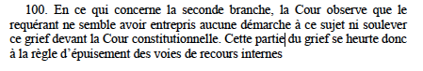
  - It has been explained above that this reason is contrary to the material truth, and this complaint was openly put forward in paragraphs 165, 168 and 169 of the application form submitted to the Constitutional Court. In addition, a disciplinary investigation was initiated against the judge who ruled in favour in the lawsuit filed on this issue and he was exiled from Adana Province to Çorum Province (see, §§ 27-28 above).
  - The ECtHR does not include these facts in its decision, which are extremely important regarding the same complaint, and they conceal them from the public (Annex 1, § 8; Application form, § 8). As can be understood, an extremely serious material error is made in paragraph 100 of the ECtHR decision, and an important complaint of the Applicant has been rejected as contrary to the material facts.
  - In Articles 101-104 of the ECtHR decision, another complaint of the Applicant is rejected, this time in violation of the well-established case-law of the ECtHR.
« 98. … La troisième branche concerne la dissolution de ses entreprises de média par décret. À cet égard, il affirme que si la Cour constitutionnelle a déclaré son grief irrecevable pour non-épuisement des voies de recours internes en faisant référence à la saisine de la Commission d’examen des actes de l’état d’urgence, une communication du Premier Ministre le priverait de l’accès à la Commission (voir paragraphe 69 ci-dessus). »
  - The media outlets owned by the Applicant were also closed with the Emergency Decree law no. 668 dated 27 July 2016, 9 months after the trustee appointment, and their assets were transferred to the Treasury without any compensation. Therefore, the Applicant claimed that in addition to the violation of the right to property (worth 225 million dollars), the freedom of the press was also violated. The Constitutional Court rejected this complaint with an illogical claim that he did not apply to the State of Emergency Commission. In fact, the right of company shareholders to apply to the State of Emergency Commission was prohibited by the Government itself with the Communiqué dated 12 July 2017 (see § 69 of the Decision of the ECtHR). Since the Applicant’s legal right to apply was expressly prohibited by the Government, the Applicant did not have the right to apply directly to this Commission, so this complaint should not have been rejected on the grounds that no application was made to the Commission. For this reason, the Applicant claimed that his right of access to a court was also violated, but the Constitutional Court could not state the complaint in its decision as it could not find any arguments to reject it. As explained above, the Ministry of Justice, which objected to every complaint as “domestic remedies have not been exhausted” in every time, did not even claim that no application was made to the State of Emergency Commission in its opinions submitted to the Constitutional Court (see for, Additional Explanations, §§ 47, 48, 56, 68-72, above).
  - Only the legal representatives of the closed institutions at the time of closure could apply to the State of Emergency Commission. The legal representatives of the media outlets that were closed on 27 July 2016 were the “trustees” and they had the status of government agents. To date, none of the Applicant’s requests have been answered by the trustees, and the Applicant’s application to the State of Emergency Commission was expressly prohibited by law pursuant to Article 4 § 2 of the Prime Ministry Communiqué dated 12 July 2017.
  - Although all these issues are explained in the application form and Annex 1, submitted to the ECtHR, the Committee consisting of three judges (ECtHR) has rejected the complaint in question with the same reason used by the Constitutional Court:
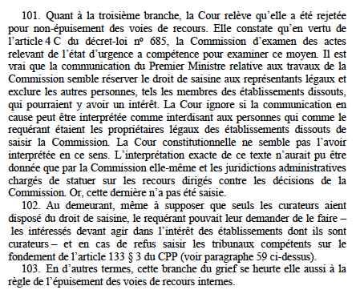
  - It is also clearly written in paragraph 69 of the ECtHR decision that the Applicant is not legally entitled to apply directly to the State of Emergency Commission: «… Les personnes non habilitées ne peuvent saisir la Commission au motif qu’ils étaient membres de l’institution ou de l’établissement dissout ou pour d’autres motifs.».
  - According to the established case-law of the ECtHR, individuals are obliged to exhaust only effective remedies in domestic law. For a domestic remedy to be effective, it must be available in theory and in practice to the Applicant (without mediation of a third party), he/she must be able to institute it directly, and it must be accessible in theory and in practice.
According to the Grand Chamber of the ECtHR, “applicants are only obliged to exhaust domestic remedies which are available in theory and in practice at the relevant time and which they can directly institute themselves – _that is to say, remedies that are accessible, capable of providing redress in respect of their complaints and offering reasonable prospects of success (Sejdovic v. Italy [GC], § 46; Paksas v. Lithuania [GC], § 75).”
  - In the present case, the Applicant’s right to apply to the State of Emergency Commission is prohibited legally (in theory) (Art. 4 § 2 of the Communiqué dated 12 July 2017). It is almost impossible to say that a legal remedy that is prohibited by law is effective in practice. If there is any doubt as to the practical effectiveness of a legally prohibited remedy, the burden of proof rests with the Government. For this reason, what the ECtHR had to do was to notify the Government of the application and decide on this issue after receiving their opinion. The Committee of 3 judges has rejected the complaint without doing this and ruled against the Grand Chamber decisions on the following grounds: “La Cour ignore si la Communication en cause (Communiqué of 12 July 2017) peut être interprétée comme interdisant aux personnes, qui comme le requérant étaient les propriétaires légaux des établissements dissouts, de saisir la Commission” (§ 101). If the Court didn’t know whether the Applicant was prohibited from applying to the State of Emergency Commission, what it should have done was to ask the Government and make a decision after obtaining their observations, not dismiss the Applicant’s complaint based on an allegation.
  - The reason why the State of Emergency Commission was not applied to is that this method was expressly prohibited by law for the Applicant. There is no decision showing that the State of Emergency Commission, which is obviously not “available” in theory, is “available” in practice. If any, the obligation to prove rests with the Government. Since this path is “prohibited” (interdisant), it is not possible to say that it is accessible to the Applicant.
  - Finally, the Committee (ECtHR) justifies the rejection decision by stating that the Applicant could have requested the trustees (curateurs) to apply to the State of Emergency Commission (§ 102). As with the reasons above, this reason is clearly contrary to the established case-law in the decisions of the Grand Chamber of the ECtHR. According to established case-law, individuals must exhaust the remedies available to them only “directly”: “which they can directly institute themselves” (Sejdovic v. Italy [GC], § 46; Paksas v. Lithuania [ GC], § 75). Just as a Committee of three judges does not have the authority to change the well-established case law of the Grand Chamber of the ECtHR, the reason that “an application should be made to the State of Emergency Commission through trustees” is also contrary to the well- established case-law. Thus, the last complaint of the Applicant, which has been examined, has been rejected in violation of the established case-law of the ECtHR.

Conclusion

  - As can be seen from the foregoing, the ECtHR’s Hamdi Akın İpek v. Turkey decision is written in utter contravention of ECtHR case law and practices from the beginning to the end. The facts are chosen and written in such a way as to justify a decision of inadmissibility, and the facts and arguments that could lead to a violation are carefully selected and not included in the decision. Almost none of the facts and arguments that would affect the outcome of the application are included in the decision. The majority of the facts and arguments put forward in the application form and Annex 1 are not specified in the decision. More than five complaints of the Applicant (rights violations) are not examined in any way, including his right to access to a court, and his right to a reasoned decision has been violated. Many violations that directly concern all the complaints are hidden without being mentioned in the decision and are hidden from public scrutiny. Since there is no other appeal against the inadmissibility decision of the Committee, the only control over these decisions is the supervision of the public reading the decision.
  - Instead of the main complaints of the Applicant, irrelevant and secondary issues are highlighted, the complaints that the Applicant did not specify are written and reasons were created for them, and the main legal issue (especially interference with the right to property and the freedom of the press without legal basis) is left out of the examination. Moreover, during the examination of the violations of freedom of the press and right to property, complaints and arguments that could not possibly be rejected are omitted and carefully excluded from the decision, in violation of Article 38 of the Convention. Since the same complaints were not examined by the Constitutional Court, a clear denial of justice has been caused regarding many complaints.
  - In conclusion, our evaluation is that the facts have been written for the sole purpose of making a decision of inadmissibility. Potentially damaging the reputation of the ECtHR, Hamdi Akın İpek v. Turkey case should be restored to the list of the Court pursuant to Article 37 of the ECHR and Article 43 § 5 of the Rules of Court.

See, Decision of the Turkish Constitutional Court delivered on 4th August 2014 Decision Number: 2016/6E – 2016/12K (https://www.ntv.com.tr/turkiye/erdogan-bedelini-agir-odeyecekler,LAhkH2jhckSDTMgtuqNowg)
https://www.mgk.gov.tr/index.php/26-mayis-2016-tarihli-toplanti)
https://www.milliyet.com.tr/siyaset/erdogandan-kirsehir-de-onemli-aciklamalar-2252704
https://www.takvim.com.tr/guncel/2016/05/30/hukumetten-onemli-feto-karari
See, for instance, https://www.youtube.com/watch?v=TMPszgwLmTk ; https://grihat.com/akar-rehin-alinmadi-onun-emrinin-disinda-bir-sey-yapilmadi/
https://www.ntv.com.tr/turkiye/erdogan-bedelini-agir-odeyecekler,LAhkH2jhckSDTMgtuqNowg
https://www.hurriyet.com.tr/gundem/bulent-arinc-silahli-teror-orgutunun-fethullahci-oldugunu-o-gece-ogrendim-bana-ahmak-diyebilirsiniz-40159063
https://www.trt.net.tr/francais/turquie/2016/08/19/article-d-ibrahim-kalin-bruxelles-a-un-probleme-555000
From this statement, it is inferred that the coup attempt of 15th July 2016 was planned and implemented in order to criminalize the Gülen Movement as well. Speaking on a German public broadcaster ZDF program on April 2, 2017, German intelligence expert Erich Schmidt-Eenboom said: “According to CIA analyses, the so-called coup attempt was staged by Erdoğan to prevent a real coup. The BND, CIA and other Western intelligence services do not see the slightest evidence showing Gülen instigating the coup attempt.” When asked by the host of the program, Maybrit Illner, “Why Erdoğan is accusing Turkish-Islamic scholar Fethullah Gülen and his followers of masterminding the coup attempt?,” Schmidt-Eenboom said: “This is the easiest way to criminalize and eliminate them” (See https://www.turkishminute.com/2017/04/03/german-intel-expert-says-erdogan-behind-failed-coup-based-cia-bnd-reports/).
http://t24.com.tr/haber/aa-2745-hakim-ve-savci-hakkinda-gozalti-karari,350362
https://www.legislationline.org/download/id/4257/file/Turkey_CPC_2009_en.pdf

